**ENG3000**

**Indoor Air Monitoring Device**

**Eleazar Arnold**

**P2765566**

Course: **Electrical and Electronic Engineering**



Supervisor: **Krishna Nama Manjunatha**

**2024/2025**

**Table of Contents**

**I. Abstract** 4

**II. Acknowledgements** 5

**1. Introduction** 6

1.1 Overall aim and objectives 7

1.2 The United Nations Sustainability Goals that the project supports. 8

**2 Project managemnt** 10

2.1 THE PROJECT PLAN 11

2.2 Major Milestones: 12

2.3 GanNt Chart 14

2.4 Risk Management 14

3 Main Body 16

3.1 Background/Literature research 16

3.1.16 How do electronic components work 16

3.1.1 Microcontrollers 18

3.1.3 Power Management and Photovoltaic Cells 21

3.1.4 Other or Less Important Components 25

3.1.6 Sensors 25

3.1.7 Chosen sensors 30

3.1.8 HT4936A 36

3.1.9 HOLTEK BA45FE240-2 37

3.1.4 3D Model 38

3.1.10 Flutter 39

3.1.5 IoT 40

3.1.14 Wi-Fi 40

3.1.11 Blynk 41

3.1.12 ThingSpeak 41

3.1.13 Firebase 41

4 Results and Discussion 42

4.1 PCB Air Monitor 67

4.2 ESP32(C++) and Flutter (Dart) Code 70

**Summary Table** 78

4.2.1 Amalgamation0404 79

**Dashboard Widget (with State)** 81

**Local Notification Listener** 82

**MQTT Connection Logic** 83

4.2.2 EspPublisher 87

5 Conclusions and Recommendations 97

5.1 Conclusion 97

5.2 Improvements 98

6 References 98

7 Appendices 101

**I. Abstract**

A project about an air motoring device that uses an esp32 with its peripheral sensors on a breadboard.

2 electronic devices were REVERSE ENGINEERED: an optical smoke alarm and a solar power bank. The circuits were studied to gain knowledge of circuit design.

leading to the creation of a device that combines both of their abilities together. A solar-powered multi-sensor fire alarm.

Applications such as Arduino IDE, Kicad and vscode will be used. Practices such as PCB design and application development will occur.

**II. Acknowledgements**

Aamir Arnold – project management guidance

Raj Rana – Cad Support

**1. Introduction**

This final year project will be about an air sensor that is used with a user interface. This user interface be an application on a device, which is connected to cloud services. This being firebase and test.mosquitto.app broker.

Air sensor parameters are Air Pressure (bars), Humidity (Relative Humidity (%)), Temperature (°C), Smoke (µg/m3) and Carbon Monoxide (ppm (parts per million)).

The user interface shows the values of the sensors, in the form of widgets, as well as alerting the user when there is a potential fire that has been sensed. It will also send a notification if the carbon monoxide level is dangerous. The app development software will be Flutter, it is written in the Dart programming language.

This project will be based heavily around IoT, as the information be transmitted over the cloud, as well as data being received. In testing the associated app/ui for the microcontroller would be used (such as the website the esp8266 runs on), the other option would be to test it on an emulator. During prototyping, the default webserver that the esp32 comes with will be used; then, later on in development, VSCode will be the IDE. Not just Arduino IDE.

A low power/deep sleep mode will be considered in the application code for microcontroller, for when the battery is low. In this mode, the device will not be publishing data as frequently and will only measure smoke, heat and carbon monoxide.

Expense of capital must be reasonable (with the assumption product may be mass produced). Getting the best value for my money, the components should be cheap enough so many devices can be made, but not cheap enough that low quality components are being purchased.

This device is solar powered, with rechargeable battery, so there will be a part of the project where power electronics will need to be studied thoroughly to power this device

## 1.1 Overall aim and objectives

1. To create a product that senses many parameters in one device.

To reduce the quantity of single-parameter fire alarms being manufactured (heat alarm, carbon monoxide alarm)

1. To minimise battery disposal.

Many batteries are disposed of incorrectly, such as straight into landfills and harm the environment

1. To promote renewable energy, specifically solar power.

This is an emerging energy sector, as well as to reduce the emissions of “greenhouse gases”

1. To reduce casualties and prevent building damage

The alarm and the application alerts user for any emergency situations (such as carbon monoxide toxicity).

1. To create an optimal breathing environment (in homes, offices, schools, etc).

Installation of the device would prevent unsatisfactory atmosphere from being made in a room, this is an assumption based on if the user would address the breathing air crisis.

## 1.2 The United Nations Sustainability Goals that the project supports.

The alarm will set off if it detects a hazardous level of carbon monoxide in the room, this will reduce the risk of carbon monoxide poisoning as the user would be promoted about this with a buzzer sound.

Improve fire safety, as there is a smoke detector inside.

As well as create an optimal living environment (in term of air quality), assuming the user will remove the issues that are creating these harmful gases.

Expanding on this point, some people may have lung problems that can’t handle specific air condition (for example hazy air). The air monitor can alert that there’s a large amount of particle density in the air to the user, and they can check what is setting the alarm off based on which parameter is in the “danger zone”.

To reduce the wastage of battery, as their composition is harmful to the environment, this is caused leaking battery acid from landfills, or any of the artificial chemicals that come along general electronics. Many batteries are wasted a year, so to use solar panels and rechargeable batteries will be helping the UN to achieve this goal, as it would reduce the batteries being used and thrown away.

This patent would also reduce the amount of fire alarms being manufactured. Instead of people buying many different sensors (such a smoke alarm or carbon monoxide alarm), they can get an ‘all in one’ product that is this air monitoring device.

This may not be a significant point, but since this device can stop fires from occurring. It would reduce combustion caused by fires. Combustion is a leading factor to global warming, as it creates “greenhouse gases”, which this product could reduce.



To help the planet’s exponentially increasing energy demand, this device will help this issue with the renewable method of photovoltaic technology. This would be in the form of solar cells. Rechargeable batteries will help this goal as there would be a ‘permanent’ storage for the renewable energy being generated.

Solar panels are becoming increasing common, mainly due to climate action, increase in energy demands and simply it being a source of free energy. Although setup costs are high.

The most significant increases have been in the grid-connected applications, particularly photovoltaics in buildings [1].

**2 Project managemnt**

The Air Quality Monitoring and Alarm System is a smart device designed to detect and monitor air pollutants such as carbon monoxide, smoke, temperature, humidity, and pressure. The project aims to integrate various sensors with a microcontroller that supports wireless connectivity, allowing real-time data transmission to a user interface accessible via the internet. This device will be mounted on ceilings, ensuring efficient environmental monitoring and timely alerts in case of hazardous air conditions.

The development process involves multiple phases, including research, component selection, hardware and software development, PCB design, enclosure fabrication, assembly, and testing. The device will incorporate a solar panel and battery for a reliable power system, while 3D printing will be used for the enclosure to house the electronics securely. Programming will be conducted in C++ and Python, ensuring robust firmware development for accurate data processing. Throughout the project, key risks such as sensor failures, connection issues, and environmental impact will be assessed and mitigated. The final product will provide a scalable and efficient solution for indoor air quality monitoring, contributing to enhanced safety and environmental awareness.

2.1 THE PROJECT PLAN

#### 2.1.1 Project Objective:

To design, develop, and test an IoT-enabled air quality monitoring and alarm system that integrates a microcontroller, sensors, and a wireless user interface. The final device will be mounted on a ceiling and capable of real-time data transmission via the internet.

#### 2.1.2 Project Scope:

* Selection and integration of a suitable microcontroller with Wi-Fi capabilities.
* Identification and compatibility testing of sensors for air quality measurement.
* Development of a user interface for remote monitoring.
* Design and fabrication of a custom Printed Circuit Board (PCB).
* 3D design and manufacturing of the device enclosure.
* Assembly, testing, and evaluation of the final product.

#### 2.1.3 Expected Outcomes:

* A fully functional IoT-enabled air quality monitoring and alarm system.
* A completed project report documenting the development process.
* Insights into potential improvements for future iterations

#### 2.1.4 Work breakdown structure

* Start-up & planning
  + Budget Agreement
  + Procurement
  + Workshop setup
  + Quality assurance
  + Timeline
* Air Sensor Development
  + Body
    - Holders for electronics (solar panels, PCB, etc.)
    - Manufacturing methods
      * Manual Assembling
      * 3D Printing
* Microcontrollers
  + ESP8266
  + Raspberry Pico
  + Micro Python
* Wireless Technology
  + Wi-Fi Modules
* Power System
  + Solar Panel
  + Battery
* Research & Development
  + Electronic Manufacturing Websites
  + Datasheets for Components
  + IoT Technologies
    - Wi-Fi Modules
* Sensor Integration
  + Carbon Monoxide Sensor
  + Smoke Sensor
  + Temperature Sensor
  + Humidity Sensor
  + Pressure Sensor
* Programming & Firmware Development
  + C++
  + Python

## 2.2 Major Milestones:

#### 2.2.1 Project Initiation & Planning (Weeks 1–3)

* 1. **Budget Agreement:** Finalised budget allocation for components, manufacturing, and development.
  2. **Procurement Plan:** Identification and sourcing of necessary electronic components, sensors, and fabrication materials.
  3. **Workshop Setup:** Establishment of a dedicated workspace with required tools and equipment for assembly and testing.
  4. **Quality Assurance** Framework: Definition of quality standards and testing protocols to ensure component compatibility and system reliability.
  5. **Project Timeline:** Development of a structured project timeline outlining key phases, milestones, and deadlines.

#### 2.2.2 Research & Component Selection (Weeks 4-8)

* 1. Identify and select a microcontroller with appropriate IoT and UI capabilities.
  2. Research and select compatible sensors and voltage regulation components.

#### 2.2.3 Hardware & Software Development (Weeks 9-16)

* 1. Develop and test the microcontroller-based firmware.
  2. Design and program the user interface.
  3. Ensure seamless integration between sensors and the microcontroller.

#### 2.2.4 PCB Design & Fabrication (Weeks 17-18)

* 1. Design PCB layout using KiCad.
  2. Submit Gerber files for manufacturing.
  3. Procure electronic components for assembly.

#### 2.2.5 Enclosure Design & Fabrication (Weeks 19–22)

* 1. Design a 3D model for the enclosure (cylindrical or alternative shape).
  2. 3D print and refine the enclosure.

#### 2.2.6 Assembly & Testing (Weeks 23–25)

* 1. Solder components onto the PCB and test connections.
  2. Assemble the device and perform functional testing.
  3. Ensure secure ceiling mounting and test device performance in a real-world setting.

#### 2.2.7 Evaluation & Documentation (Weeks 26–28)

* 1. Analyse test results and identify potential improvements.
  2. Document project findings, challenges, and recommendations.
  3. Finalise project report and presentation.

### 2.3 GanNt Chart

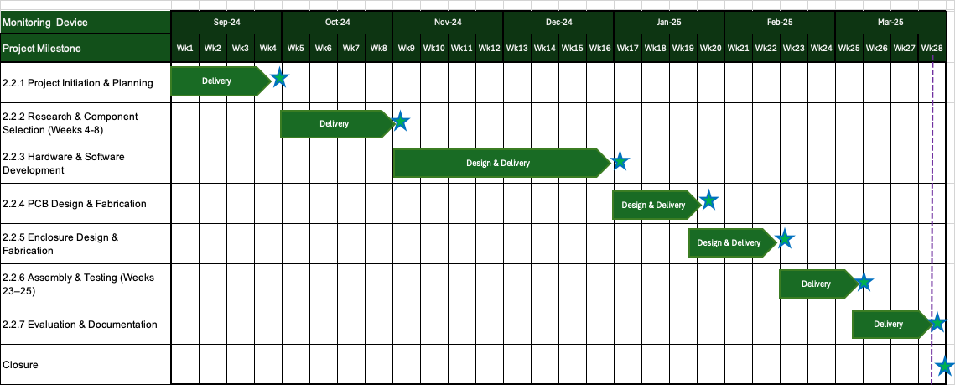A Gantt chart will be used to visually map out the project timeline, ensuring that each phase is tracked effectively from initiation to completion. It will outline key milestones such as research and planning, component procurement, hardware and software development, PCB design, enclosure fabrication, assembly, testing, and final evaluation. The chart will also help monitor dependencies between tasks, allocate resources efficiently, and adjust timelines as needed to mitigate potential delays.

### 2.4 Risk Management

Effective risk management is crucial for the successful development of the IoT-Enabled Air Quality Monitoring and Alarm System. The project involves multiple hardware and software components, each presenting potential challenges that could impact functionality, safety, and overall performance. Key risks include sensor failures, which may prevent accurate air quality detection, connection issues that could hinder real-time data transmission, and PCB design flaws that might require multiple iterations. Additionally, manufacturing risks such as faulty 3D-printed enclosures or supply chain disruptions in component procurement could delay the project timeline. Environmental concerns, particularly the proper disposal of electronic waste, are also considered to minimize long-term ecological impact. To mitigate these risks, the project will incorporate robust testing protocols, redundancy in sensor selection, iterative prototyping, and strict quality control measures. A structured risk assessment process will be followed, ensuring that each identified risk is evaluated based on its likelihood and severity, with contingency plans in place to address potential failures efficiently.

|  |  |  |  |  |  |  |  |
| --- | --- | --- | --- | --- | --- | --- | --- |
| **Risk Name** | **Description** | **Potential Cause** | **Severity (1-10)** | **Likelihood (1-10)** | **Risk Level (1-10)** | **RPN** | **Mitigation Strategy** |
| Sensor failure | Sensor may be faulty and fail to send a signal. | May allow fire or carbon monoxide to go undetected. | 2 | 3 | 3 | 18 | Use multiple sensors for redundancy and conduct thorough pre-deployment testing. |
| Connection issues | User may not be able to access live data from the device. | None | 1 | 5 | 3 | 15 | Ensure a reliable Wi-Fi module and provide offline functionality (e.g., local alarms). |
| Electronic waste | When the device expires, it may be improperly disposed of, harming the environment. | Environmental damage from harmful chemicals or synthetic materials. | 7 | 6 | 5 | 210 | Use recyclable materials and provide clear disposal instructions. |
| 3D printing defects | The 3D printer may produce a faulty or fragile enclosure. | None | 1 | 2 | 1 | 2 | Conduct test prints and refine design parameters before final production. |
| Device falling | The device may detach from the ceiling, causing injury or damage. | Various | 3 | 2 | 3 | 18 | Ensure secure mounting design and test attachment under different conditions. |
| Delivery issues | Component shipping delays could impact project timelines. | Various | 2 | 5 | 3 | 30 | Order components well in advance and have backup suppliers. |
| Fire destroys device | The device fails to detect a fire and is incinerated. | Device, building occupants, and furniture. | 9 | 1 | 1 | 9 | Use fire-resistant materials and conduct regular functionality tests. |

# 3 Main Body

## 3.1 Background/Literature research

<https://www.youtube.com/watch?v=IT19dg73nKU>

Most LiPO batteries are 3.7V. -> Use the same circuit style as the solar power bank that was purchased.

MT3608 - Variable boost converter

Inputs of 2-24 dc. Output up to 28. 97% eff. Has potentiometer to adjust Vout.

S9V11F5 - 5 Volt buck boost converter

Gets very hot so that’s a negative.

TP4056

Charging module to connect to the battery in parallel lot he boosts converter.

Still need to integrate a button and a buzzer. The reset button will function just like the reset button on the ESP32. The buzzer will sound if any of the parameters reach a dangerous level.

Also need to integrate a notification system into the Flutter app for when the alarm goes off.

Need to alert users when the batteries require changing or when the system is in low power mode.

That means a boost converter way before the battery, then a boost converter just after.

8 solar panels will connect to a central node, 8 live to one node and 8 gnd to another node. These 2 nodes get connected to the + & - terminals of a TP4056, respectively.

But just before the wire from the live node reaches the TP4056 + terminal, there will be a Schottky diode in the way.

This diode will prevent power from the battery from going to the solar panel and being wasted. This would happen in low-light situations, such as at nighttime.

will now install a notification system, and it will involve the Google Firebase service.

Firebase and Flutter are fully compatible since both technologies are developed by Google. This ensures a seamless integration, allowing developers to leverage the strengths of both platforms effectively. Furthermore, Firebase has created its own dependencies specifically for Flutter, which means that first-party support is readily available, providing a robust foundation for building high-performance mobile applications.

### 3.1.1 Microcontrollers

#### 3.1.1.1 Microcontrollers workings

They are fabricated like cpus and gpus, but their function is much simpler than them. They are made for embedded systems that don’t require a standard computer for it to work.

#### 3.1.1.2 Micro Python Pyboard

Micro python is an optimised version of the Python 3 programming language that is designed to be used for microcontrollers. Not to be confused with the board “Pyboard” which Is the official board of micropython is also designed for devices that are constrained by their hardware, meaning it can run on devices with as little as little as 256KB of flash memory and 16KB of RAM. It has a STM32F405RG microcontroller, 168 MHz Cortex M4 CPU with hardware floating point and 1024KiB flash ROM and 192KiB RAM.

It includes UART, I2C and SPI serial communication methods, as well as providing many GPIO pins for its users. However, this microcontroller unit needs to be used with hardware that has Wi-Fi capabilities, such as an ESP8266.

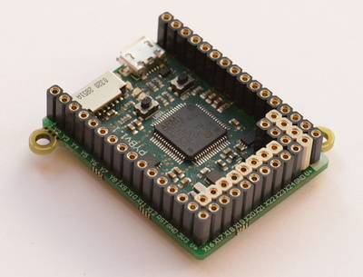

Figure 1: Micro python image

#### 3.1.1.2 Arduino Uno

This is a fantastic device, and it is perfect for beginner electronic projects. It is coded in C++, and uses simplified libraries of C++ for ease of use for the user. It has an open-source software, so all the design files, schematics and source code are freely available to everyone.[2]

Like the Micro python unit, it has UART, I2C and SPI serial communications. As well as needing a Wi-Fi module for itself to be able to do IoT activities. Its microcontroller is the Microchip ATmega328P (8-bit AVR core). Which has a clock speed of 16 MHz on the Uno board, though it can be overclocked to 20 MHz (at the 5 Volt maximum). Flash memory: 32 KB of flash memory (0.5 KB is used by the bootloader). SRAM: 2 KB. EEPROM: 1 KB.

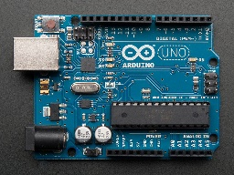

Figure 2: Arduino Uno Image

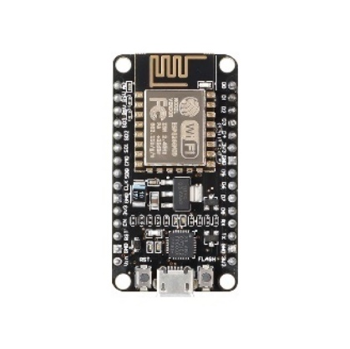

#### 3.1.1.3 ESP8266

ESP8266 is a Wi-Fi microcontroller, with built-in TCP/IP networking software. It is produced by Espress if Systems, who are based in Shanghai, China., and the price of this device is fairly low.

Mainly used for IoT projects, this microcontroller was used in tandem with an Arduino Nano in last year’s project. Programmed in C++ in the Arduino IDE, making sure to set the devboard as node 1.0 something. It also supports UART, I2C and SPI serial communications as well.

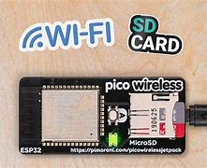

#### 3.1.1.6 ESP32

The ESP32 is the 8266’s successor. It does everything it does but with more features and better hardware performance. It has additional dual-mode Bluetooth along with its Wi-Fi capabilities. The 32 means that the microprocessor is 32 bits.

The ESP32 series features a Tensilica Xtensa LX6 microprocessor available in both dual-core and single-core versions, an Xtensa LX7 dual-core microprocessor, or a single-core RISC-V microprocessor. Each variant includes built-in antenna switches, RF baluns, power amplifiers, low noise receive amplifiers, filters, and power management modules.

Wi-Fi and Bluetooth modules consume a lot of current.

#### 3.1.1.4 Raspberry Pi Pico W

This is microcontroller is identical to the Raspberry Pi Pico but with added Wi-Fi capability. The Raspberry Pi Pico is a microcontroller made in 2021 by Raspberry Pi, with this W version being releases in the summer of 2022. These boards are very cheap at $6. It supports UART, I2C and SPI serial communications. It features a dual-core Arm Cortex-M0 CPU capable of achieving a clock speed of 133MHz. The memory includes 264KB of on-chip SRAM and 2MB of on-board QSPI flash.

#### 3.1.1.5 PIC Microcontroller

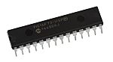

A very basic microcontroller family manufactured by Microchip Technology. It is derived from the derived from the PIC1640[1][2]. The word PIC is generally assumed to mean programmable interface controller [11]. Although the acronym has no meaning anymore and is just a name for these kinds of MCUs.

The book just referenced claims that PIC chips are cheaper and run faster than competitors. It uses Harvard something RISC.

PIC32MZW1is a board with built in native Wi-Fi.

WINC1500/WINC1510 is a Wi-Fi module made by microchip technology. Can connect to many microcontrollers from PIC.

<https://uk.rs-online.com/web/p/microcontrollers/1654769>

### 3.1.3 Power Management and Photovoltaic Cells

#### 3.1.3.1 Switched Mode Power Supply

This is a small yet efficient way of converting voltage values. Increasing, decreasing or inverting the input voltage.

There are many reasons why one would want to change the voltage value.

More efficient than a standard full bridge rectifier with a transformer. But sometimes they're used with them in specific cases.

It uses many different electronics such as inductors, capacitors, transistors, resistors and diodes to provide the desired effect. The inductor Is used in place of a transformer to act as the magnetic factor of the circuit.

The output voltage depends on the duty cycle of the switching element, which is commonly a MOSFET.

There are many topologies of the switched mode power supply, such as charge pumps.

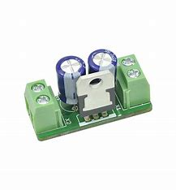

#### 3.1.3.2 Charging module/breakout board

May consider using a USB-C or similar port to charge the device, similar to charging a smartphone. This may also be necessary to regulate the solar panel's current and battery.

#### 3.1.3.3 Lithium-Ion Battery

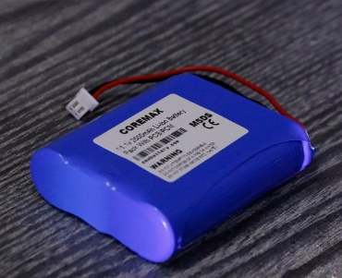

It works based on the principle that the cathodes and anode are made from different compounds to one another. Inside the battery, they are repeatedly charging and discharging electricity.

There are many types of lithium-ion batteries, one example that can be used is Lithium Manganese Dioxide; this compound would make up its own cathode and the anode is graphite.

Li-Mn02 batteries do not contain any toxic liquids or gases, they pose no major pollution problems [7].

#### 3.1.3.4 Lithium Polymer (LiPo) Battery

Lithium has 3 protons. It works because of an electrochemical reaction just like tradition batteries. The Lithium IONs move between the anode and cathodes, which are usually made out of carbon.

This can be implemented by the use of the use of a battery pack, then connect it to power line on the PCB, possibly use a voltage regulator to regulate the unpredictable electricity.

#### 3.1.3.5 Rechargeable battery (Nickel Cadmium)

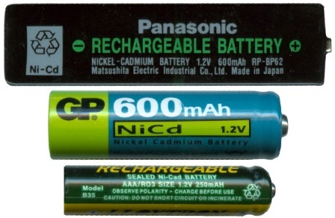

Works with the same principle as the lithium-ion battery, but the components are Cadmium and Nickel Oxide. The reversible reaction goes back and forth as the battery is charged and discharged. Their major advantages are long maintenance-free life, excellent storage capability, and high-power output over a wide temperature range [6].

#### 3.1.3.6 Mini Solar Panels

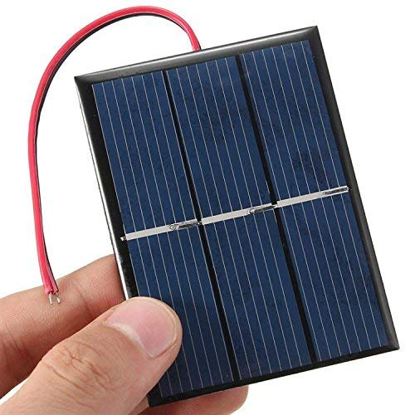

This sheet converts light energy from the sun into electrical energy, it does this by utilising the photoelectric effect. This is when photons excite silicon atoms (specifically their electrons) inside of the sheet’s structure. These excited electrons are processed into electrical current.

Since the maximum voltage from a single silicon cell is about 600mV, cells are connected in series to reach the desired voltage [5].

#### 3.1.3.7 Small solar panels

Solar panels work by the photoelectric effect; the study of solar panels is called photovoltaics. The photoelectric effect works when electromagnetic radiation hits the solar panel, which is made out of some special silicon wafer. This generated DC. This means that for a solar panel to power a home, an inverter (Digital to Analog converter) is needed.

In this project, this is not a problem as it runs on DC; adding regulators to avoid electricity damaging the circuit would be a great concept.

Lithium batteries are becoming increasingly common use in portable appliances such as computers, cameras, personal organisers and mobile phone. [5]

Blocking diodes protect the battery from short circuits in the solar array, as well as the batteries from discharging through the solar cells when they are not illuminated. [5]

With P and N-type silicon, light goes through it, and then the electrons get excited, producing DC.

#### 3.1.3.8 LM317

This is a voltage regulator IC with 3 pins. It is capable of maintaining a steady voltage between 1.25 and 37 volts and is capable of outputting up to 1.5 amps. It uses Zener diodes and such in a voltage divider circuit within the IC. There is a simple formula that is used to calculate the output voltage from this IC. It has thermal and short-circuit protection.

#### 3.1.3.9 7805

This is another voltage regulator IC that accepts 7 to 35 volts, and outputs a stable voltage of 5 V. It is part of the 78 IC series; the last 2 digits tell the user what the output voltage is. The circuit configuration of this IC is simple as only 2 electrolytic capacitors are required to be connected between the middle pin and each of the outer pins. Mainly used in low power projects, because it only outputs 5 volts.

[**https://predictabledesigns.com/how-to-pick-the-right-voltage-regulators-for-your-design/#:~:text=To%20select%20a%20voltage%20regulator,use%20a%20boost%20switching%20regulator**](https://predictabledesigns.com/how-to-pick-the-right-voltage-regulators-for-your-design/#:~:text=To%20select%20a%20voltage%20regulator,use%20a%20boost%20switching%20regulator)**.**

### 3.1.4 Other or Less Important Components

#### 3.1.4.1 Buzzer

A single frequency small 5v buzzer from the lab was used.

#### 3.1.4.2 LED

May incorporate a simple LED that triggers when a parameter has reached a value. Or to flash in increments

### 3.1.6 Sensors

Most of these sensors work by varying the voltage level based on external parameters

#### 3.1.2.1 Pressure

The image above depicts a barometric pressure sensor designed to measure air pressure in kPa. This may use a piezo-electric mechanism, where the force is mechanically transferred onto the crystal [4].

Converts physical pressure from the air into an electrical signal that can be processed. It is a type of MEMS (Micro Electromechanical System).

Air pushes against a diaphragm inside of the sensor, and the usually a capacitive or piezo resistive structure usually detects this movement. This causes a change in the parameter (could be voltage or capacitance)

This data is then sent out of the sensor digitally or analogy.

Very common in digital tyre pressure gauges.

#### 3.1.2.2 Humidity

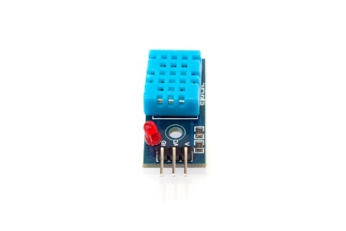

Measures amount of water vapour in the air. Absolute humidity is measured in g/m3. Relative humidity measures the amount of water vapor in the air compared to the maximum amount the air can hold at a given temperature and air pressure (although its usually just compared to temperature such as with the DHT11). It is expressed as a percentage. Relative humidity is the most common way of representing humidity values.

It can work by capacitive, resistive or temperature methods.

Resistive method would use a salt, polymer, or conductive material whose resistance changes with humidity. More water means better conduction which then means lower resistance. The circuit measures this decreasing/increasing resistance and then converts it to %RH.

The thermal method works by using two thermistors/temperature sensors. One is sealed in dry gas and the other is exposed to ambient air. The difference in thermal conductivity equates to the amount of water vapor in the air. Not affected by temperature or pressure like sensors that display relative humidity. This would mainly be used in weather stations

Capacitive has two plates exactly like below. A polymer or oxide layer absorbs water from the air. This layer exists between two electrodes (forming a capacitor). As humidity changes, the dielectric constant of the layer changes, which alters capacitance. The sensor measures that change and converts it into a relative humidity value (%RH).

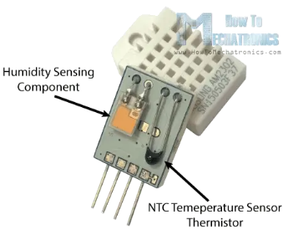

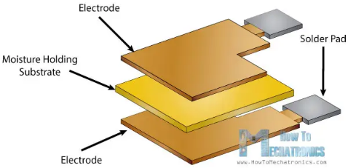

The images above are demonstrating how they work. This is a DHT11, it is considered to be a low-cost humidity sensor, yet it yields okay results with a 10% tolerance (decent for simple projects). Output current appears to be proportional to ΔC [3].

The DHT11 is an affordable humidity sensor with a 10% tolerance, suitable for basic projects.

#### 3.1.2.3 Temperature

Thermistors will measure temperature and have their temperature values shown in degrees Celsius.

Thermistor is a passive component that changes is resistance with varying temperature.

Resistance values are determined by the semi-conducting materials that are used to manufacture it, the can be oxides of manganese, nickel, copper, cobalt or iron.

They’re ground into a powder, mixed with a binder and heat-treated to produce a ceramic material.

The leads may be inserted in the slurry before heat treating or added afterward, while being strategically spaced to take advantage of the conducting properties of the thermistor medium.

It is commonly included inside of other modules such as the DHT11 and the BME280.

[How Do Thermistors Work?](https://www.sciencing.com/thermistors-work-4709009/)

There are other ways sensors can measure heat excluding thermistors, these are thermocouples, semiconductor sensors, resistance temperature detector and infrared sensors.

#### Analog Devices CN0537 Reference Design for UL-217 Smoke Detector - Electronics-Lab.com3.1.2.4 Smoke

(May need to be a module instead on just a sensor)

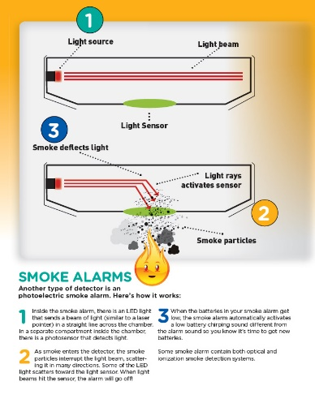

Photoelectric sensor is a device that uses photoelectric effect to convert optical signals into electrical signals [10].

An LED will be shining away from the sensor, so the sensor's signal will be null. If smoke particles enter the alarm through the designed opening, the red light bounces off the smoke and onto the photoelectric sensor, which sends an electrical signal that can be processed.

<https://www.nfpa.org/education-and-research/home-fire-safety/smoke-alarms/ionization-vs-photoelectric>

It can also work with radiation/ionisation, where the smoke will decrease the amount of ionisation received, triggering the alarm. The radioactive element that is used is usually americium-241.

#### 3.1.2.5 Carbon Monoxide

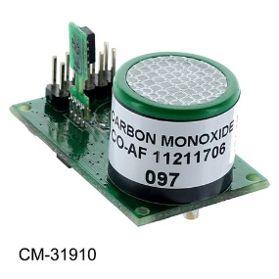There are 3 main types of carbon monoxide sensors: electrochemical, metal-oxide semiconductor and biomimetic.

Electromechanical works by using a tiny chamber with electrodes and an electrolyte (which is usually sulfuric acid). When CO enters, it reacts with oxygen at the sensing electrode to form CO₂, all while creating a small electric current. This current is proportional to the amount of CO in the air. Electronics such as opamps inside the sensor module amplify this signal as analogue data processes it into a value that resembles CO concentration (ppm).

A Metal Oxide Semiconductor sensor is a circuit on a silica chip, and it works because of a heated ceramic sensor coated with a metal oxide (like SnO₂) that reacts with CO. CO changes the resistance of the metal oxide. The circuit measures this change to detect gas concentration.

The colorimetric sensor works by CO reacting with a chemical gel or pad that changes colour. Some use a photoelectric sensor (ldr sister) to detect the colour change electronically. This method is doctors use unpractical s mainly to detect carbon monoxide concentration in the blood. It seems to be a ‘one-time use’ component.

### 3.1.7 Chosen sensors

#### BME280 sensor example - Arduino Learning3.1.7.1 BMP280

The BMP280 is digital barometer that sends data to a microcontroller on the i2c protocol.

It has an advanced counterpart called the BME280 that measures heat and humidity as well.

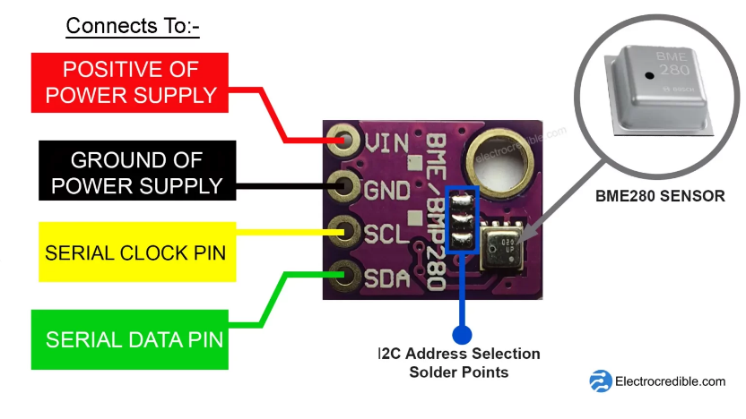Works due to the piezo resistive effect, changing kinetic energy to electrical energy. The voltage will change, corresponding to the vertical level the air has pushed the square to.

This component will communicate to the ESP32 using the I2C protocol, connected to the SDA and SCL pins.

#### 3.1.7.2 DHT11

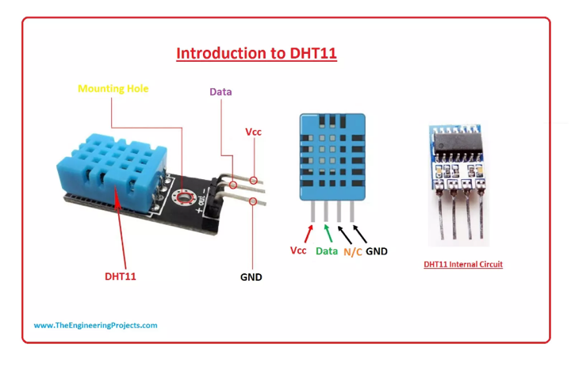

Image shows that there is an IC on the module that probably has an opamps to amplify the signals coming from the humidity and temperature components. Their functions are displayed below.

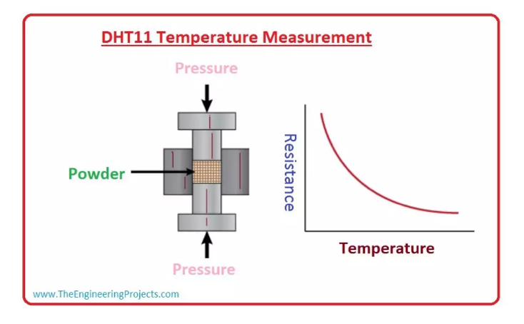

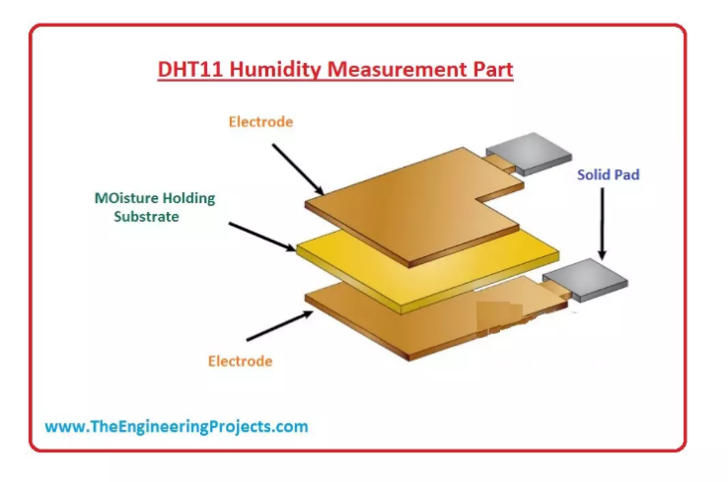

It appears that the moisture holding substate acts as a dielectric, which varies the potential difference between the electrodes. DHT11 is a digital humidity sensor and thermistor.

DHT22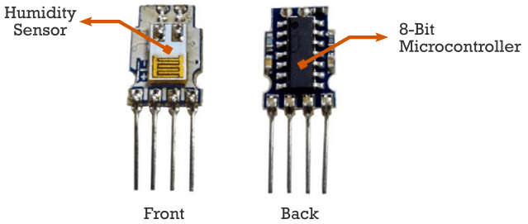

DHT22

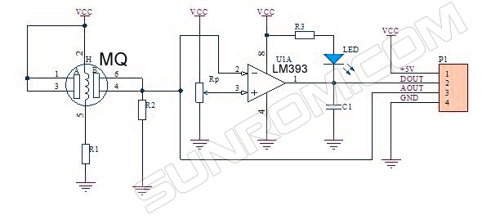

The DHT22 is the same but more accurate than the DHT11, the final choice of humidity would be likely to use the DHT22. It uses i2c serial communication, and it will allow me to connect it to the same pins as the BMP280.

#### 3.1.7.3 MQ-7

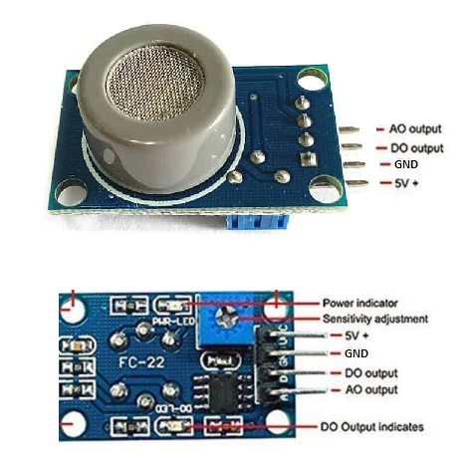

MQ7 is a gas sensor part of the MQ series. Its designed mainly to detect Carbon monoxide in the surrounding air. It has an analogue output and digital output. Based on the appearance of the sensor its seems that it used an electrochemical reaction to detect rouge carbon monoxide particle.

#### 3.1.7.4 GP2Y1014

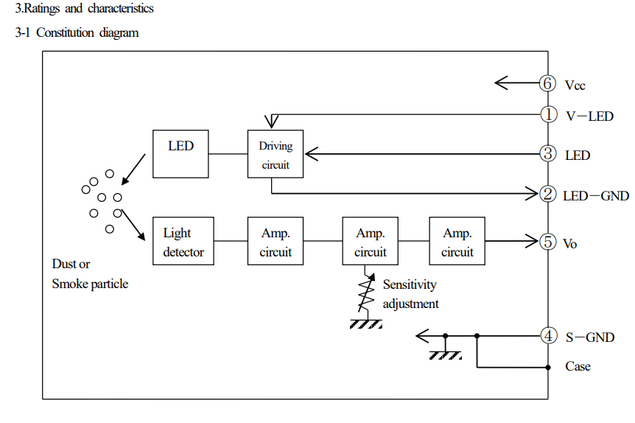

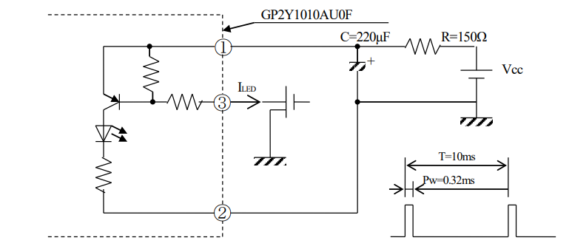This is the block diagram and schematic for the optical smoke sensor. It uses and IR LED an LDR, inside a chamber, to assess varying smoke levels.

### 3.1.8 HT4936A

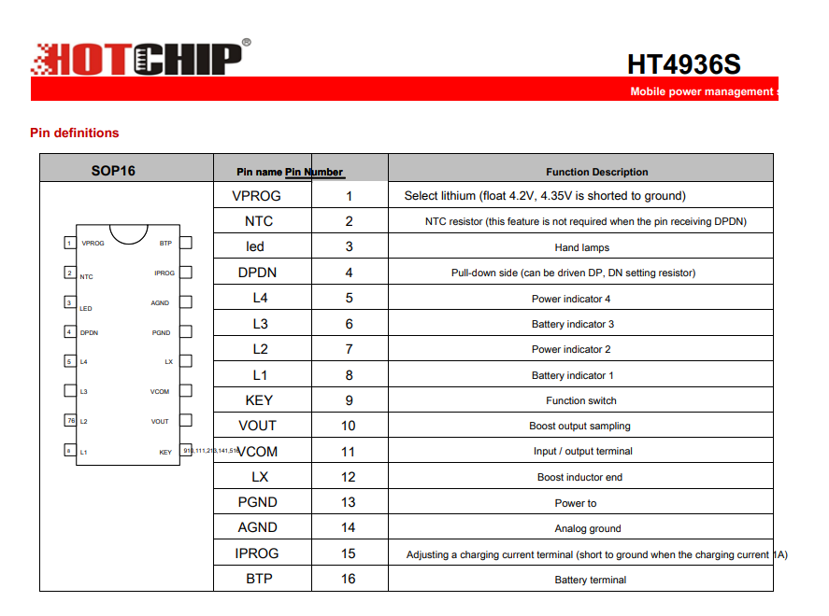

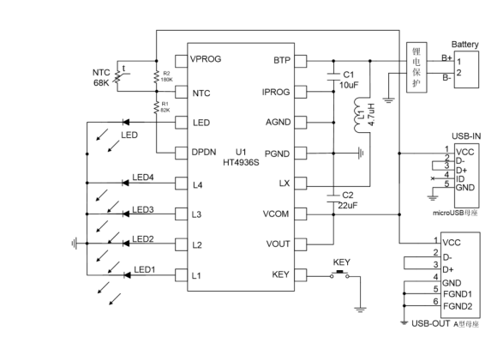

This is the microcontroller on the battery pack. It is an HT4936A chip. It is specifically made for power electronics. The datasheet for this specific one could not be found, but its counterpart, the HT4936S, which is almost identical, was discovered. Doing a Google search of this microcontroller yields results of said microcontroller on a circuit board that looks very similar to the one that was salvaged.

This is used in tandem with a 3.7V LiPo battery, which is then connected to a switched mode power supply to increase the voltage to 5V

### 3.1.9 HOLTEK BA45FE240-2

This is the SoC inside of the fire alarm, it has an 8-bit microcontroller at the heart of it. It runs up to speeds of 8MHZ, uses Flash to store programs, RAM for temporary variables, and EEPROM for non-volatile data such as calibration values. It operates between 2.2-5.5V, and it has power-saving modes. It integrates digital and analogue features. Built-in timers and PWM outputs; UART/SPI/I2C communication to send information to the microcontroller.

Includes 2 operational amplifiers (op-amps) to amplify small signals from smoke-sensing components (like photodiodes).

Has comparators and 12-bit ADCs to convert those analogue signals into digital values.

A built-in temperature sensor helps compensate for environmental changes that could affect readings.

At the start of this machine, there is an infrared LED and a photodiode that work in tandem with each other to detect smoke particles in between each other. This carrying voltage level will be connected to the opamps.

### 3.1.4 3D Model

CREO or SolidWorks are options for making 3d cad models.

The university uses CREO for the 3d printer so that I will stick with this for now.

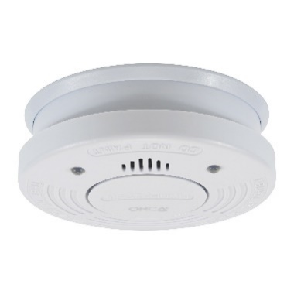A loosely circular object with internal space for the battery and PCB. The underside of the device would need to be attached to the ceiling.

This image on the right is an example of what a regular smoke alarm would look like.

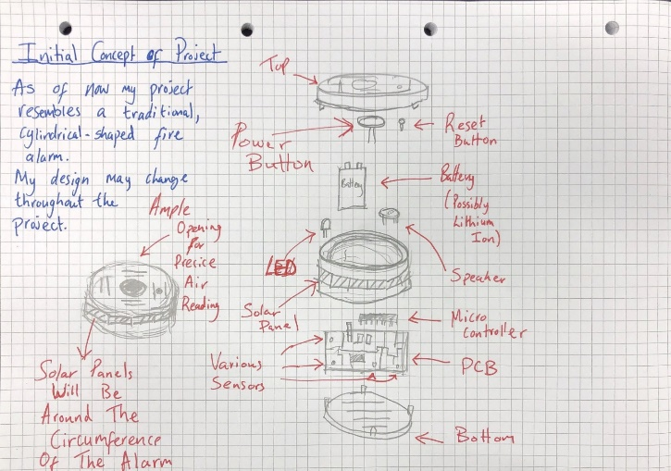

Design concept: octagon with solar panel on each side.

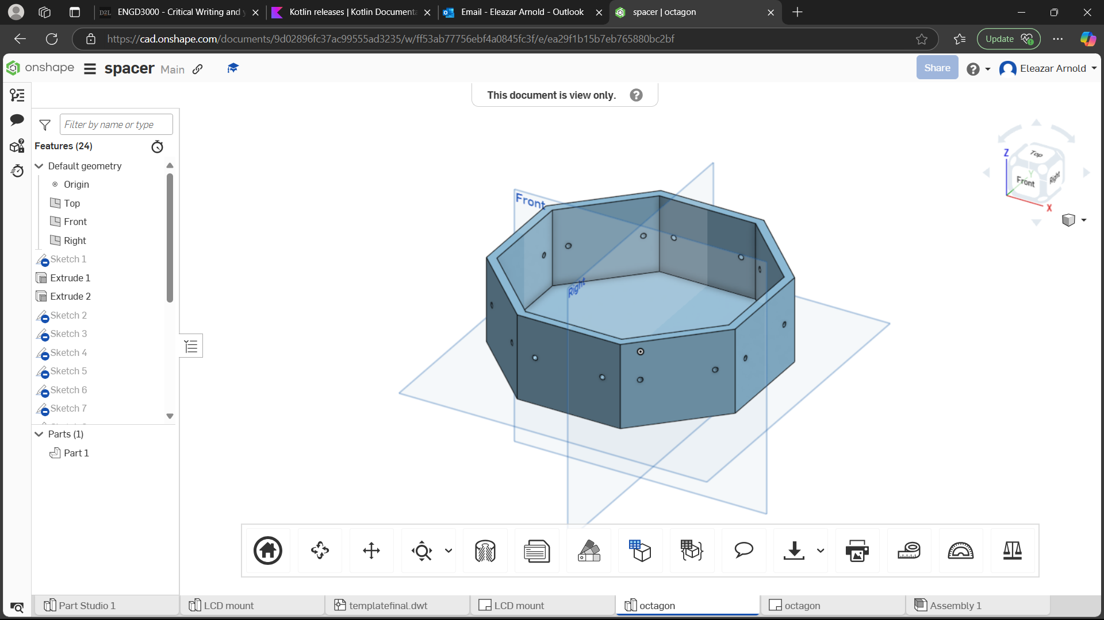

Raj provided assistance during the 3D design of the fire alarm enclosure.

### 3.1.10 Flutter

Flutter is a platform that utilises the Dart programming language, and it is a cross-platform framework for building smartphone apps. C++ and JavaScript have a significant influence on Dart, particularly in terms of its syntax and data types. It was created by Google in 2017.

It is excellent for designing a user interface.

This platform will be integrated with MQTT, allowing sensor data to be transmitted into a reliable database. The Flutter application can then be downloaded onto any smartphone and accessed anywhere as long as there is an internet connection and the MQTT server is cloud-based.

It is cross-platform, so it can be downloaded onto iOS and Android devices.

Android is programmed in Kotlin or Java; both are interchangeable. Google prefers to code in Kotlin.

A disadvantage of this is that it’s not in native smartphone code, as it's cross-platform, and it’s a high-level language, meaning that it will take some time to compile compared to a native program like in Java.

### 3.1.5 IoT

The IoT is a network of interconnected everyday objects equipped with embedded sensors that makes them able to communicate with one another and with the users [8]. The IoT enables easy access and interaction with a wide variety of devices such as for instance, home appliances, surveillance cameras, monitoring sensors, actuators, vehicles, displays and so on [9].

An application for IoT is that its technology and be used to transmit data in large buildings, such as warehouses.

#### 3.1.6.1 MQTT

Stands for Message Queuing Telemetry Transport. Its system is based on publishing and subscribing, devices publish messages onto a specific topic, and whichever device is subscribed to the topic receives the message.

It is designed for devices with low bandwidth and is great for exchanging data between

There is a client and broker, the client is any peripheral that connects to the database (broker) reading and writing data. The broker is a server, which can be in the cloud, LAN, or even emulated on a PC. Another example, ignoring my project, is a smart-home thing where you can control the electrical appliances such as lights or TV, remotely on a device far away from your home. There is a large use of cloud brokers, such as Mosquito or Node Red

A message consists of a header, encryption and payload. The payload is the ‘flesh’ of the message and is the being sent/received.

MQTT is a lightweight messaging protocol designed for Internet of Things (IoT) devices, focusing on power efficiency and minimal bandwidth consumption. It facilitates communication with low-power devices such as sensors, actuators, and household appliances, effectively managing data transmission [8].

In agriculture, MQTT monitors environmental factors like soil moisture and temperature, aiding farmers in making timely decisions. In industrial automation, it oversees the manufacturing process to ensure quality and identify systemic issues. In transportation, MQTT tracks traffic lights, parking meters, and the real-time locations of public transit, while accounting for ecological impacts and low bandwidth needs.

HTTP and MQTT are distinct communication protocols. HTTP operates as a request-response protocol for large data transfers, typically used for web pages and media. In contrast, MQTT follows a publish/subscribe model, allowing multiple clients to subscribe to topics and receive messages asynchronously. This design optimizes MQTT for small data transmissions and reduces network overhead and power consumption, making it ideal for applications requiring low bandwidth.

MQTT is a protocol that can be implemented in various programming languages. Client libraries available for MQTT are found in languages such as C/C++, Java, Python, and JavaScript, along with Node.js, Ruby, Go, PHP, and Swift. These libraries communicate with an MQTT broker, which can also be implemented in multiple languages.

In MQTT (Message Queuing Telemetry Transport), Quality of Service (QoS) describes how reliably a message gets delivered. There are three levels of QoS: QoS 0 (At Most Once), QoS 1 (At Least Once), and QoS 2 (Exactly Once). Each level offers a different level of reliability [9].

Quality of service 0 (At Most Once):

This is the simplest option. It means that the message is sent once, but there is no guarantee that it will arrive. If the message gets lost, it won’t be sent again.

Quality of service 1 (At Least Once):

This option makes sure the message arrives at least once. However, if there are network problems, the message might arrive more than once. The sender waits for a confirmation from the receiver before sending the next message. If the confirmation isn’t received, the sender may send the message again.

### 3.1.14 Wi-Fi

Wireless fidelity allows wireless communication by utilizing a router that connects to the internet through an Ethernet cable linked to a central hub located in a city or data center. The router emits radio signals, allowing any compatible device within its proximity—such as smartphones, tablets, and laptops—to connect wirelessly. This connection facilitates local area network (LAN) access, enabling devices to communicate with each other and access the internet simultaneously.

Importantly, Wi-Fi does not always require an internet connection to function. For example, devices like the ESP8266 and ESP32 can be configured as access points, allowing local device connectivity without internet access. This capability is particularly useful in scenarios like setting up a local network for IoT devices, enabling them to communicate and share data directly with each other.

Taking about the esp32, the decision to use it has been made [19].

### 3.1.11 Blynk

This IoT platform allows users to create projects based on IoT, without having to do any coding. It is great for beginners or prototypes without having to write lots of code. It has a very simply interface and gets straight to the point by displaying the data that matters.

### 3.1.12 ThingSpeak

This is an open-source analytics software, that allows users to see live data in the cloud. It is coded in ruby. It is like BLYNK but is a bit more challenging to use. It’s like a big server in the cloud where the data can be written and read from.

### 3.1.13 Firebase

Firebase is a Google-owned backend service for developers creating simple apps; it is used in the project for the FCM functionality. Google Firebase

Google Firebase is a suite of cloud-based development tools that helps mobile app developers create, deploy, and scale their applications [3].

The Key Features of Google Firebase:

Securely sign in users with options like email/password, Google Sign-In, and Facebook Login. Has a cloud-hosted NoSQL database that synchronises data in real time across all devices, ensuring apps stay current even offline.

-Cloud Messaging can Send messages to users' devices, including push notifications and content updates, even when apps are not in use.

Crashlytics allow users to track and resolve app crashes with detailed reports to quickly identify and fix issues.

Performance Monitoring: Gain insights into app performance by tracking metrics such as CPU usage, memory consumption, and network traffic.

A cloud service for testing apps on various devices and configurations to ensure compatibility and performance.

# 4 Results and Discussion

Here is a Fire Angel FA6620-R optical smoke detector with a 10-year life lithium-ion battery. the circuit board was extracted out of the casing, and its components were analysed. Reverse engineering the board so Its architecture can be practiced in the project’s circuitry.

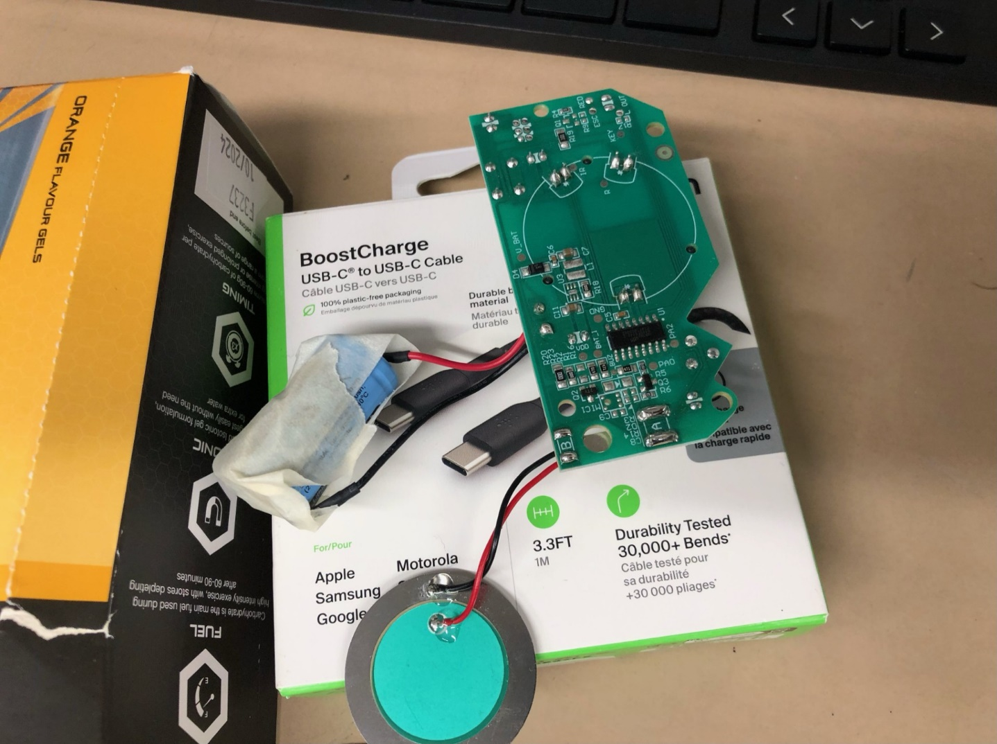

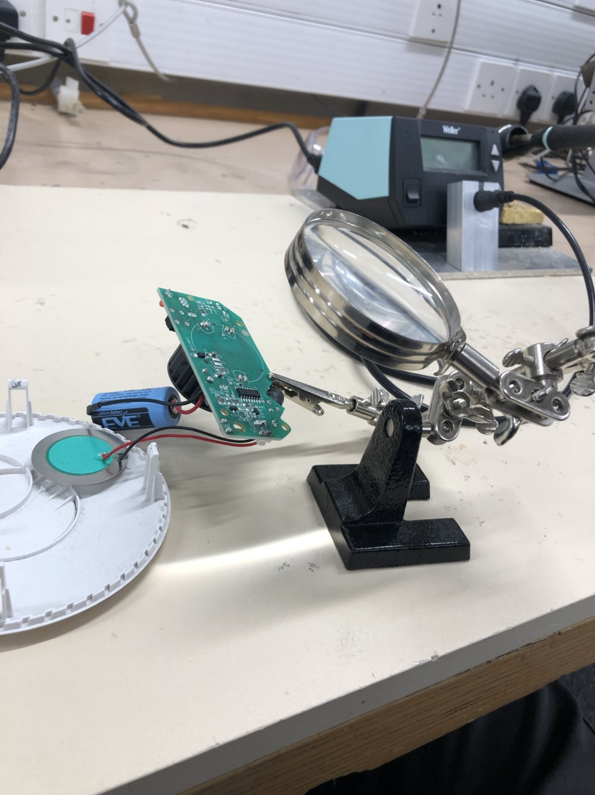

It operates on a BA45FE240-2chip. This is an 8-bit flash microcontroller unit, specifically designed for smoke detection circuits.

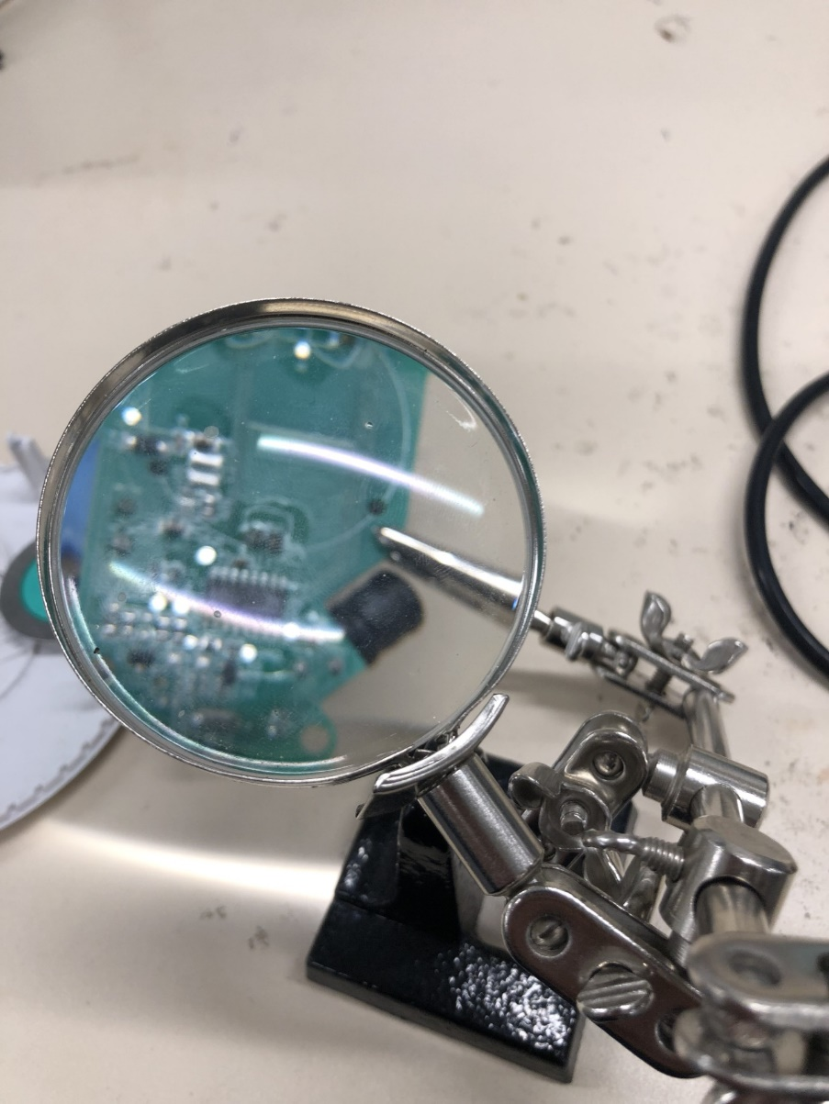

A magnifying glass observing the minuscule details of a PCB. The circuit features one inductor, along with numerous resistors, capacitors, and operational amplifiers.

It will need to operate at 3.3 volts due to the ESPs operating voltage. 32. Actually, there’s a voltage regulator on the board

**11/02/2025**

Ordered 3 parts on Amazon

used a solar power battery system lithium-ion on a power plant.

**22/02/2025**

added a dht11, bmp280 and mq7 on a breadboard with an esp32, they all work. Ignore the esp2 on the right side; it doesn’t work, and it's unknown why it's still there.

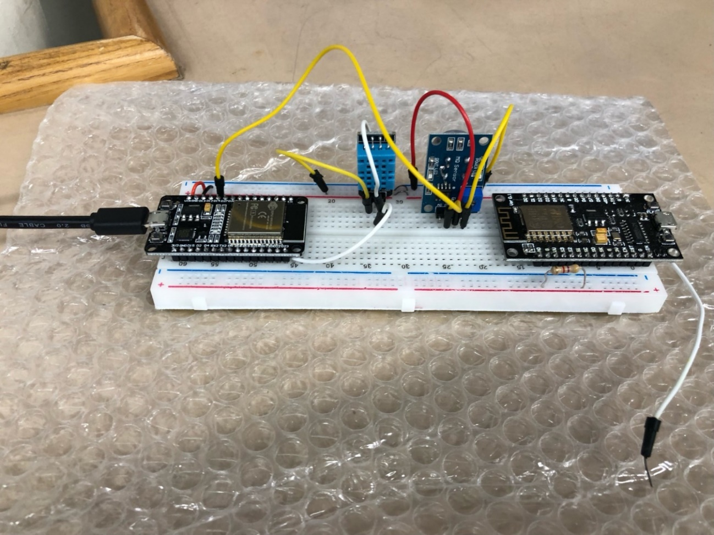

Dissembled a solar power bank.

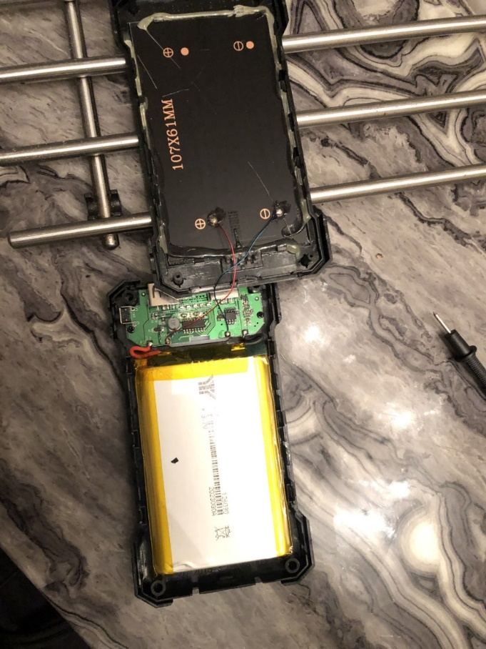

Lithium polymer battery 3.7v dc, connecting to what appears to be a booster converter or a switched-mode power supply [6].

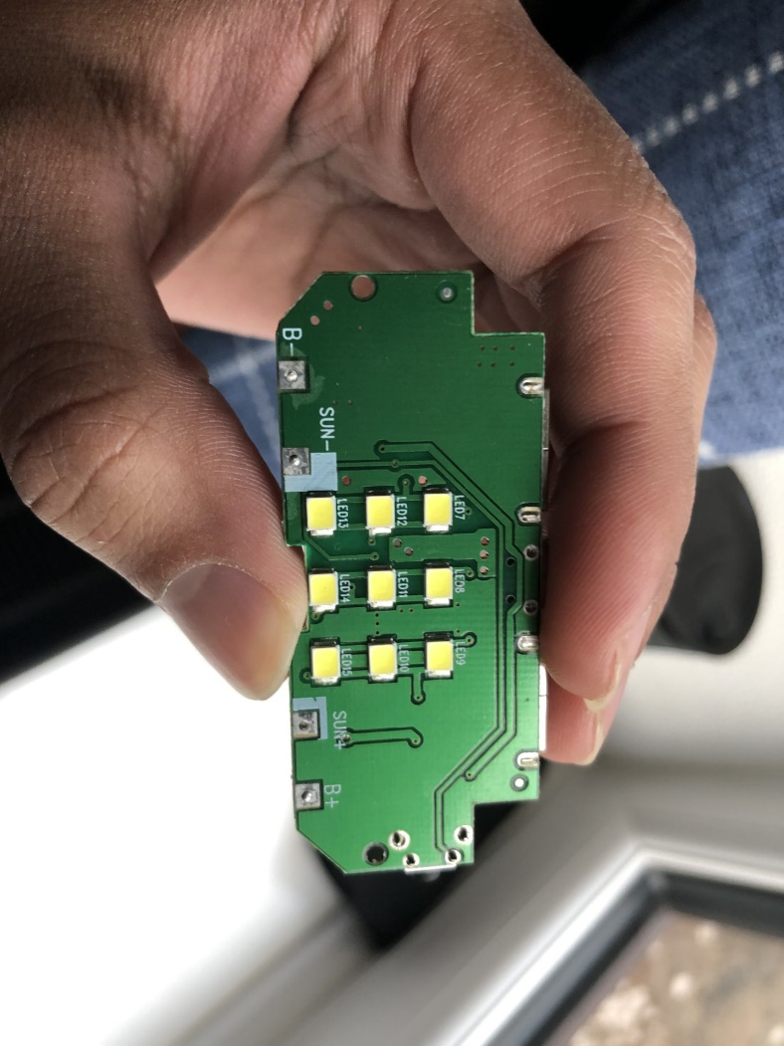

On the back of the PCB, there appears to be a lot of vias being implemented on this board.

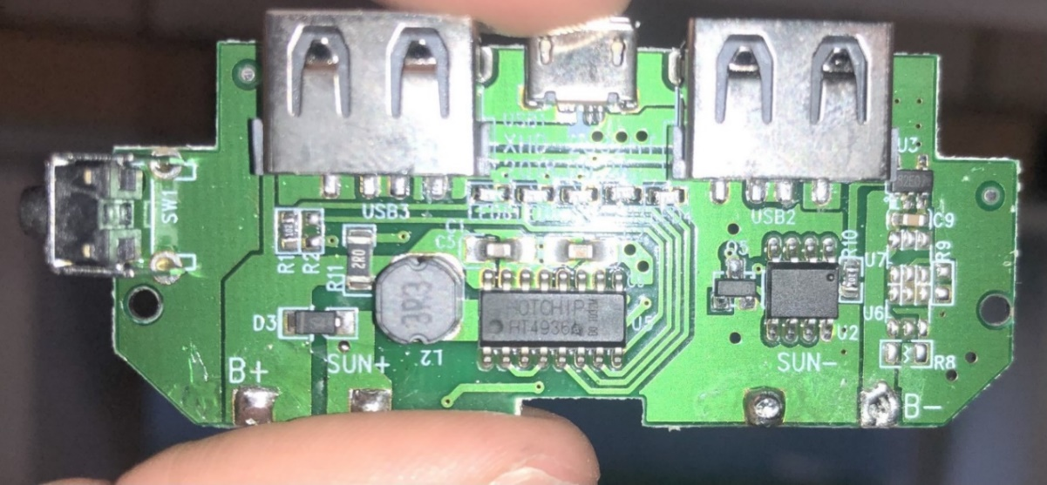

The large solar panel we've been working with has the potential to significantly enhance our project, inspiring us to explore its full capabilities.

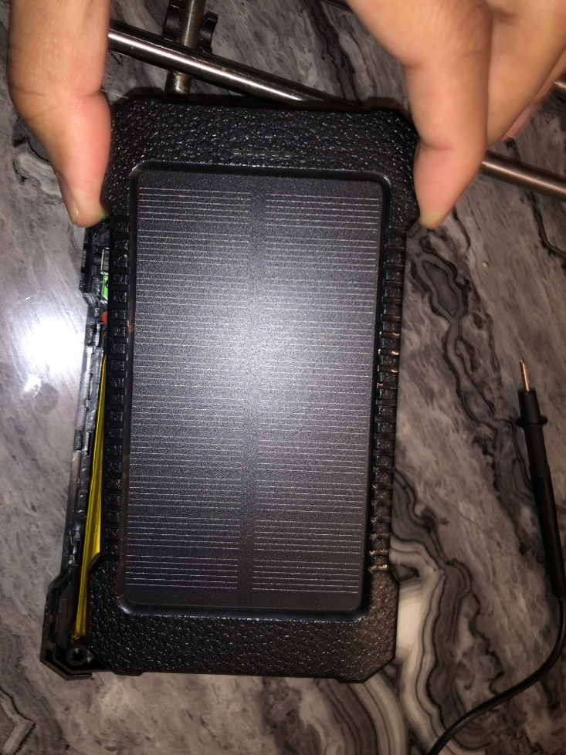

This solar power bank has shown that a voltage boost IC if a standard 3.7v lithium battery will be used.

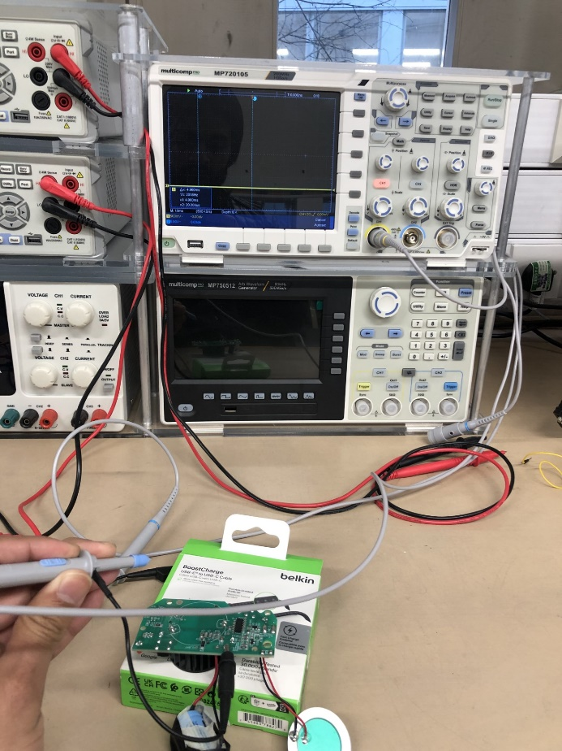

Seeing the DC voltage values across different parts of the optical smoke sensor circuit.

It appears that voltage high is in certain places. The probe was used to monitor every pin on the HOLTEK BA45FE240-2 SoC, and it shows that the pins were on an active high [10].

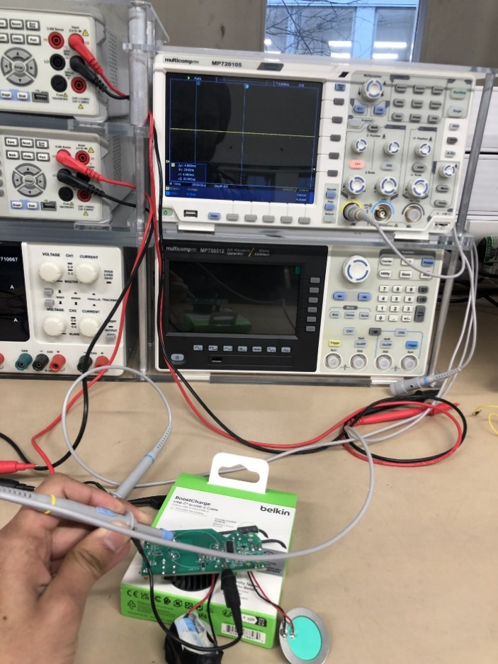

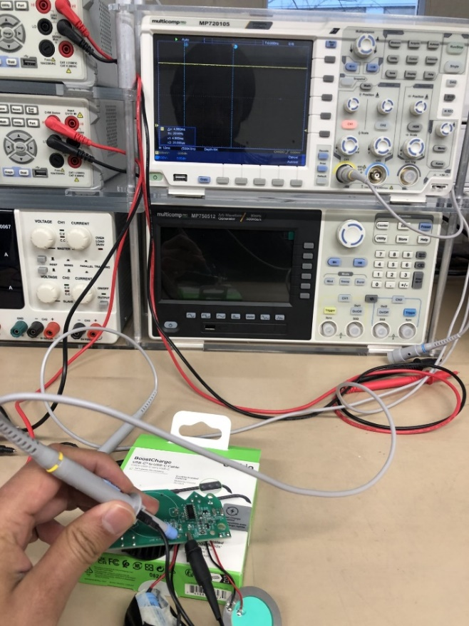

The optical smoke sensor circuit has high voltages in interesting places.

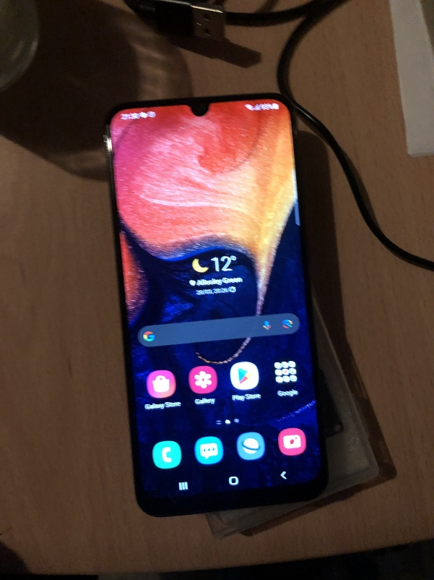

New phone: It was necessary to access the settings to enable developer mode.

This is a Samsung Galaxy A50.

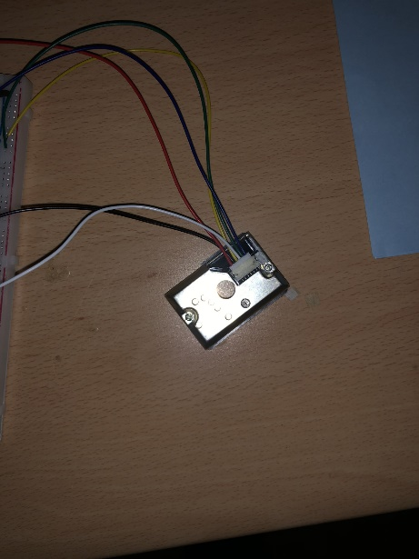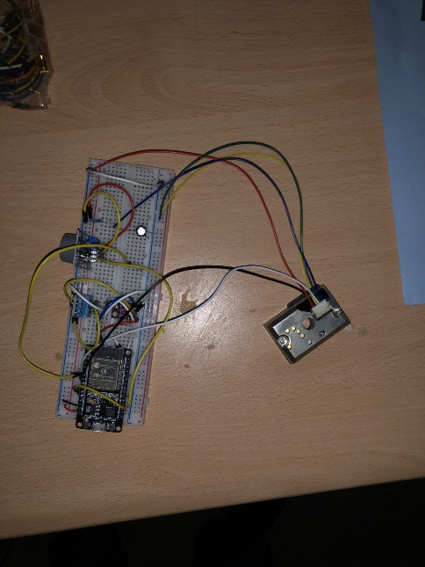

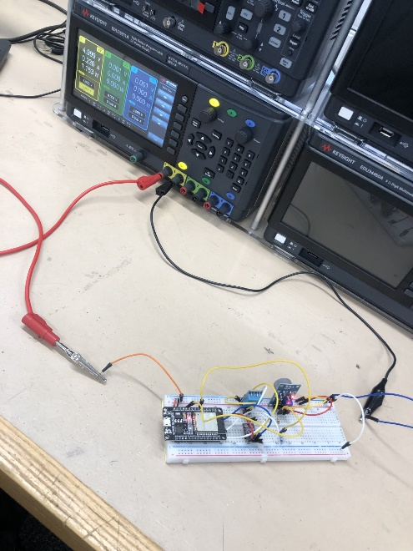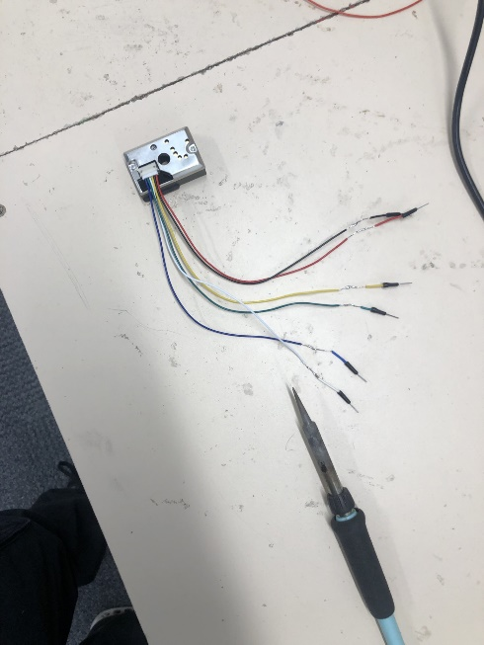

Experiment: measure current and voltage in a parallel and series configuration.

Also see the power consumption of the whole circuit.

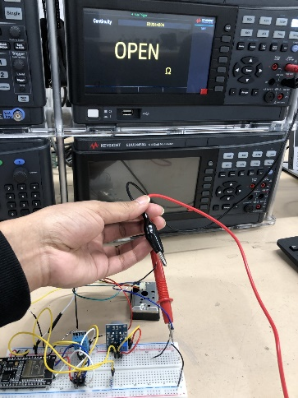The optical sensor is ruined. A continuity test confirms that the IR LED is broken.

Here is some code for a basic setup for the smoke detection system, but the sensor is not working now. We need to wait for a new sensor to arrive before we can test it in the demonstration.

#define VOUT 34  // VOUT from GP2Y1014

void setup() {

  Serial.begin(115200);

  pinMode(VOUT, INPUT);

}

void loop() {

  int raw = analogRead(VOUT);

  float voltage = raw * (3.3 / 4095.0);

  float dustDensity = (voltage - 0.9) * 100.0;

  Serial.printf("ADC=%d, Voltage=%.2f V, Dust Density=%.1f μg/m3\n", raw, voltage, dustDensity);

  delay(5000);

}

It processes analog voltage values, it will need to be going into pin 34 of the ESP32.

Measuring the DC voltage and current of a leftover circular solar cell from a previous project to assess its performance and potential for integration into our current solar power project.

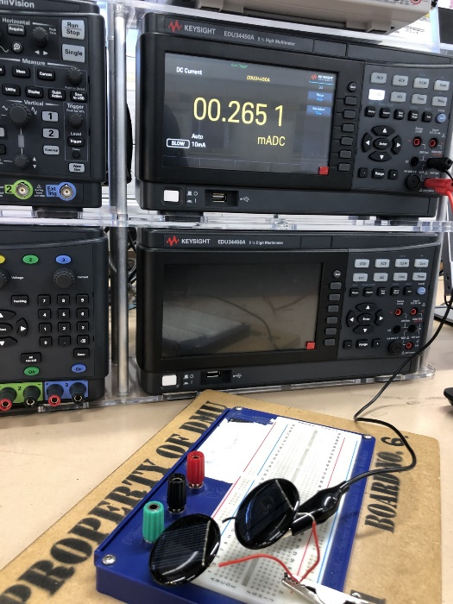parallel current normal light

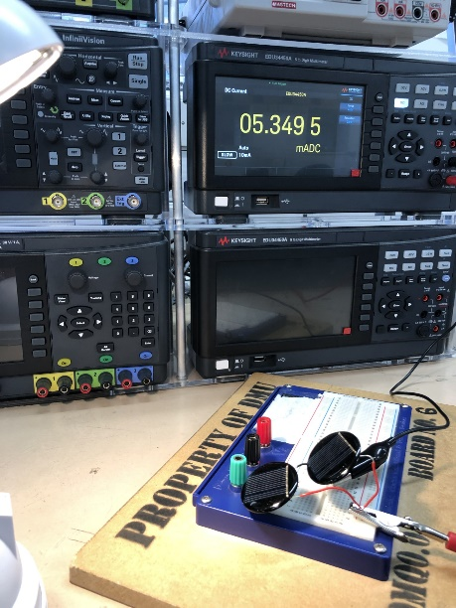

parallel current intense light, possibly infrared, as hands can detect thermal energy from the lamp source.

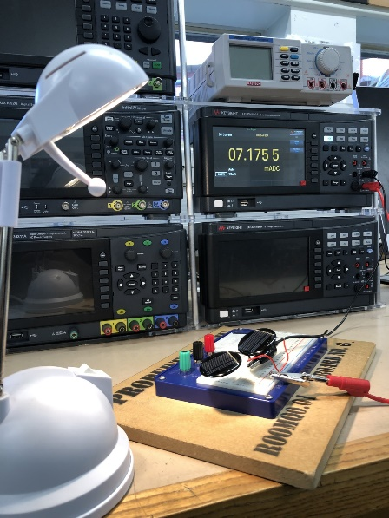

Parallel current intense light gives very high current.

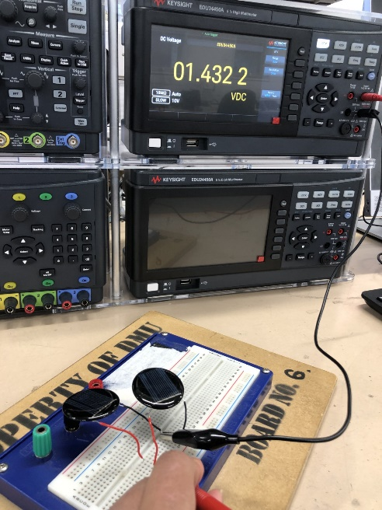

Parallel voltage normal light, voltage level = 1 cell voltage.

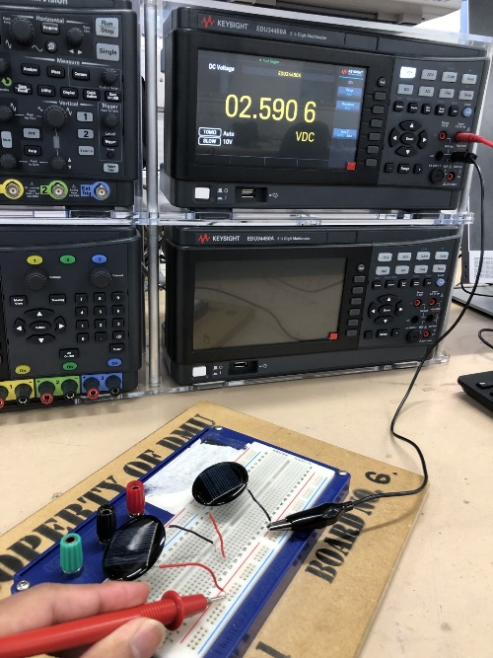

Series voltage normal light

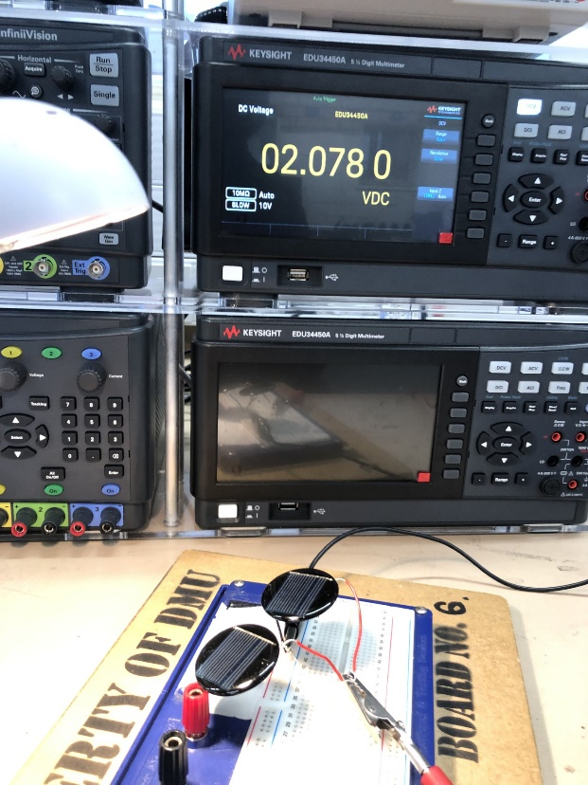

Parallel voltage intense light

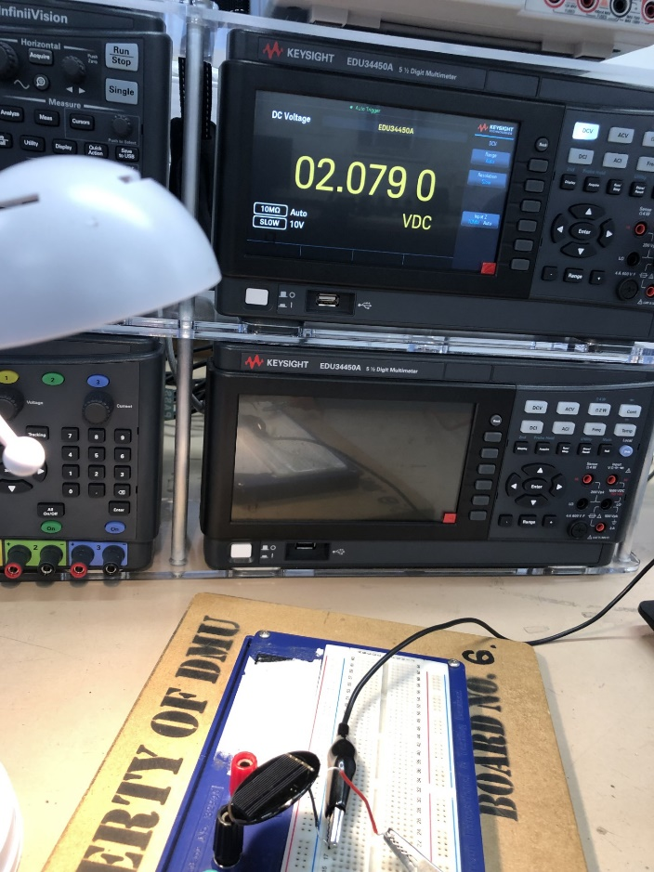

Singular solar cell, so I guess series voltage

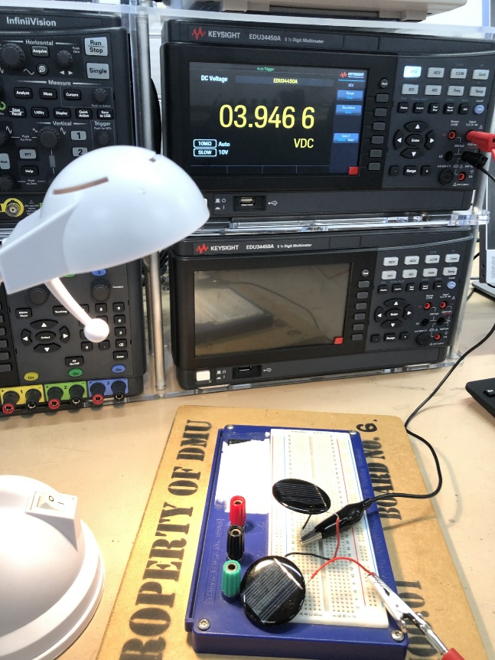

Series voltage intense light

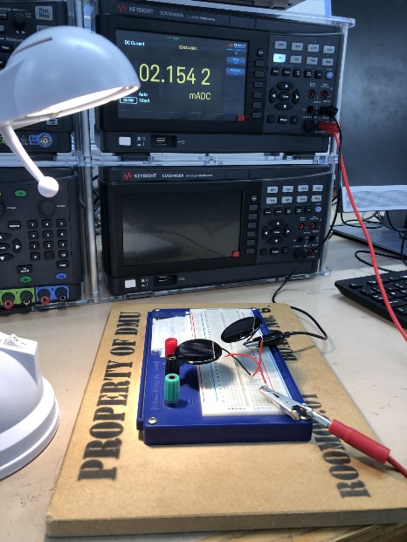series current intense light

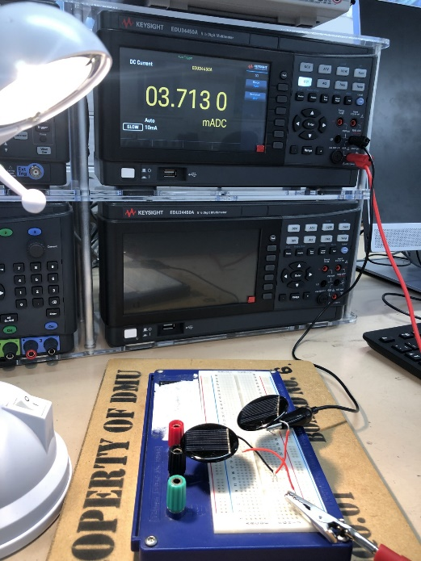

series current intense light

This assessment has yielded satisfying results. Showing that room lighting can charge up a solar cell.

Also, different light affects the solar panels differently, as well as different locations, angles and obstacles.

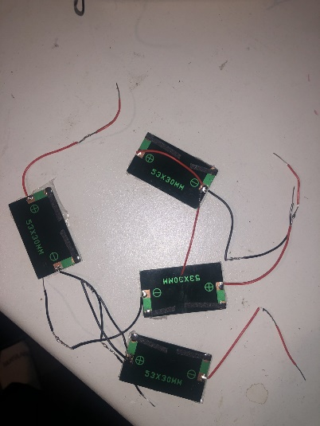

Soldered extra wires onto the new solar cells. They're surprisingly very efficient.

Repeated the same experiment with these solar panels; confirmed they all work. Nee dot change data to implement the power circuit into this.

R * I2 to figure out the power, R was constant, so the mA was near the test. A table of all the maximum power point values. For 4 solar m=panels, an 8.2 k resistor was the best. This will halve when eight solar panels are used because of the maths. This was used for the new solar panels tested in parallel indoors.

|  |  |  |  |
| --- | --- | --- | --- |
| Resistor (I) | Current (mA) | Voltage (V) | Power (mW) |
| 1200 | 0.235 | 0.282 | 0.0663 |
| 8200 | 0.262 | 2.148 | 0.5629 |
| 9750 | 0.235 | 2.291 | 0.5384 |
| 11000 | 0.219 | 2.409 | 0.5276 |
| 12000 | 0.207 | 2.484 | 0.5142 |
| 18000 | 0.148 | 2.664 | 0.3943 |
| 20000 | 0.137 | 2.74 | 0.3754 |
| 22000 | 0.126 | 2.772 | 0.3493 |
| 24000 | 0.113 | 2.712 | 0.3065 |

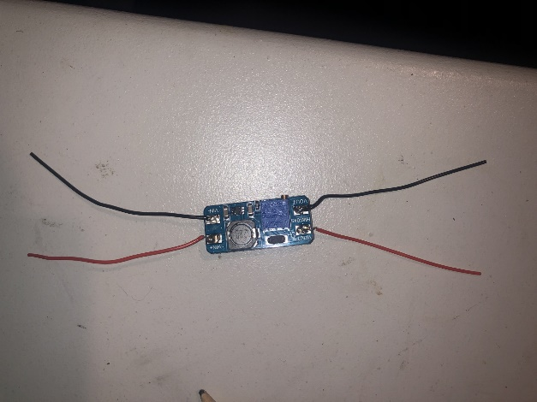 mt3608

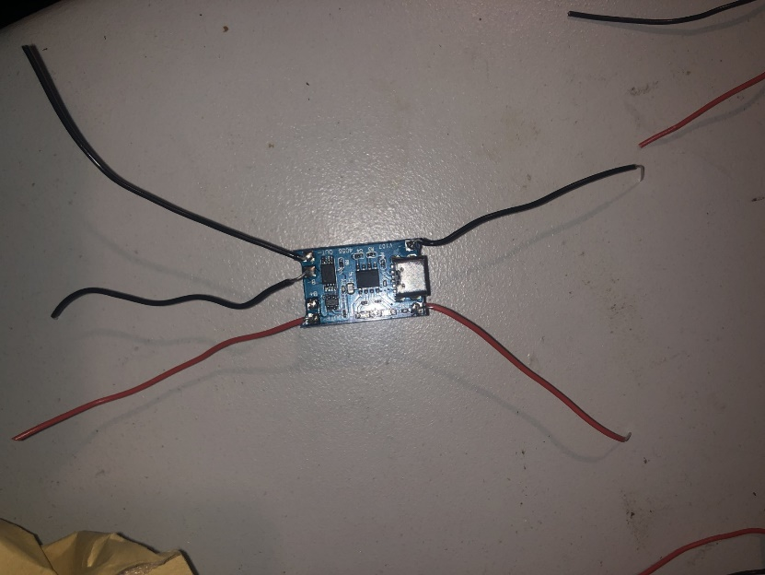 tp4056

Soldered wires on all the input and output terminals of the 2 power electronics.

then experiment with mt3608

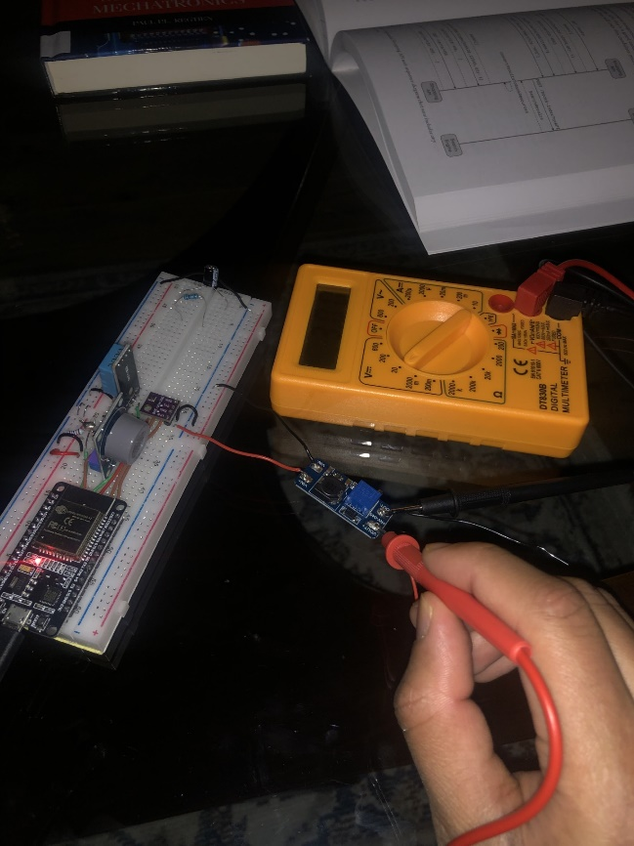

Measure the voltage of the MT3806 module that is connected to the 3.3v Vout of the ESP32. Managed to get a 5v output.

## 4.1 PCB Air Monitor

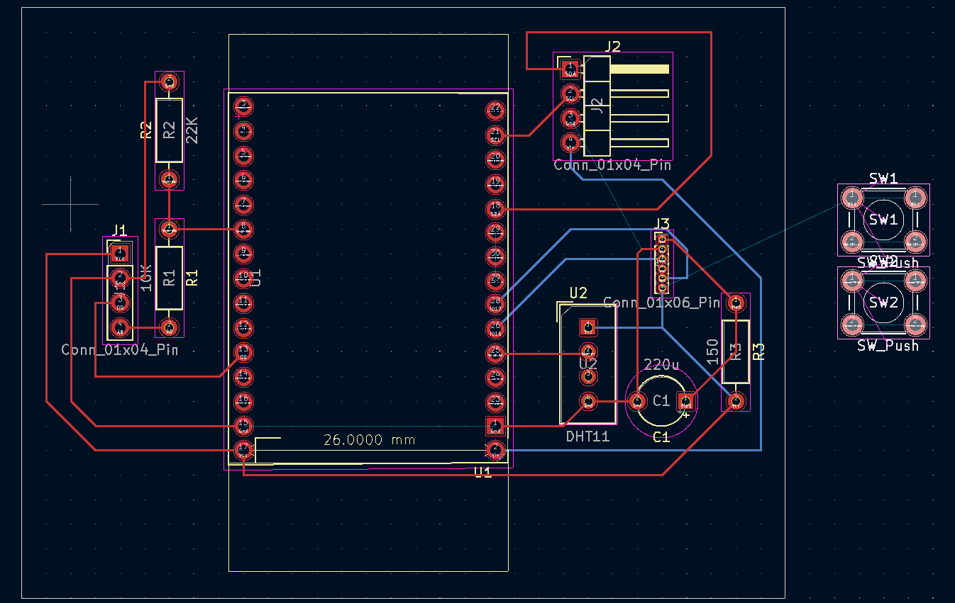

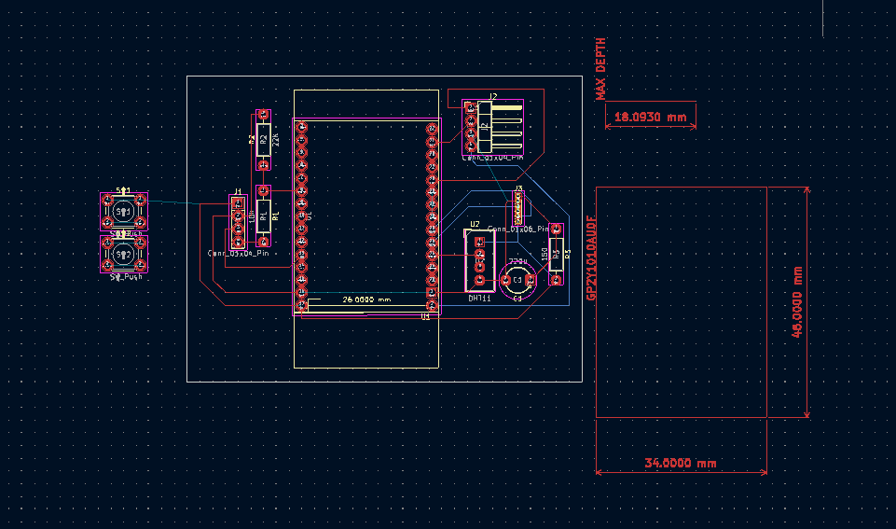

This is a schematic in KiCad that shows how the final PCB will look.

Attempts have been made to make it as small as possible.

Create a new symbol for the ESP32 to match the one bought from Amazon.

Editing the footprint that was provided on Kicad.

Made the connection as clear as possible (almost identical to how its configured on the PCB)

reused footprints from my multimeter project from last year.

In the PCB editor, boxes were added around some of the components to account for each module's dimension to make space around them so all of them fit around the PCB.

Most of the holes are going to be connector pins as the modules have all of the smd components already soldered onto them. There will be a through holes for the optical smoke sensor circuit, though

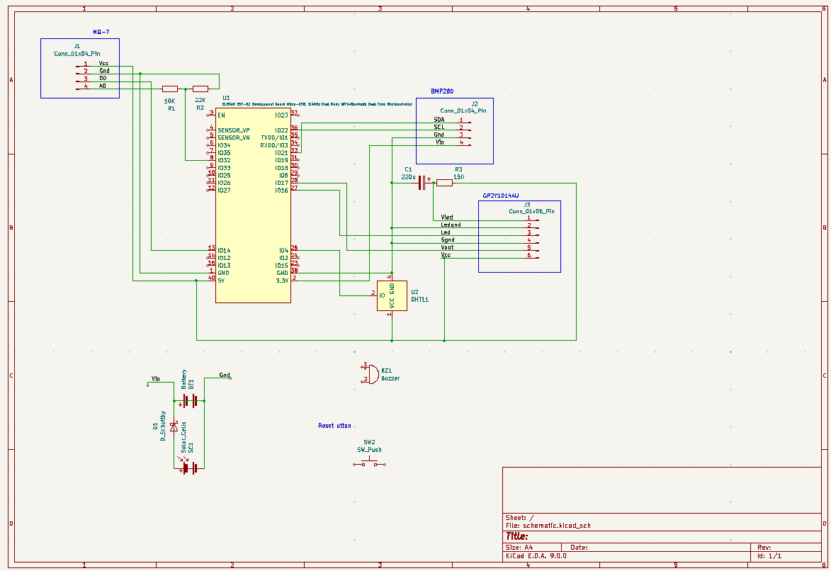

This is a repeat of the prototype on the breadboard

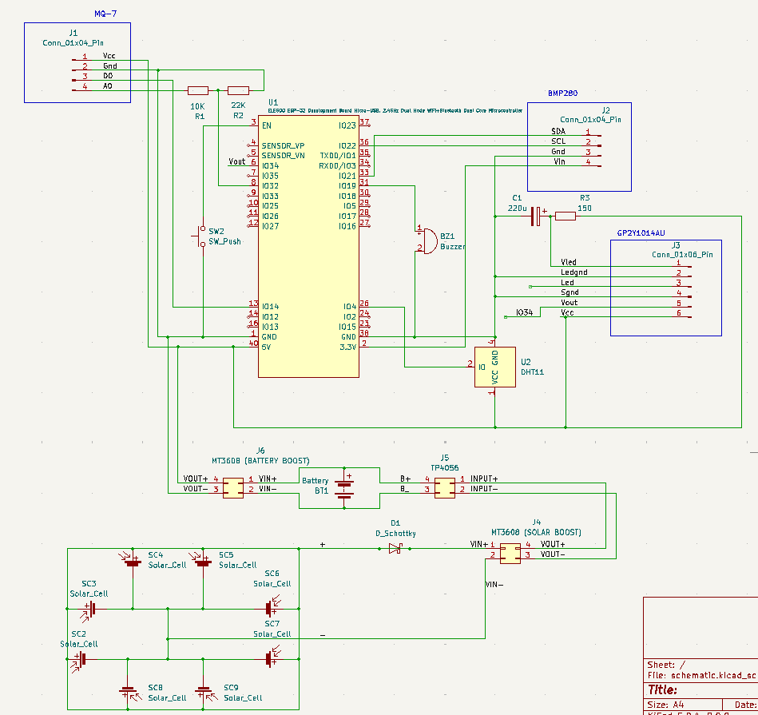

The finalised configuration.

The pcb couldn’t be ordered on time, but the schematic has been created. So the demo will have to use a stripboard. But the pcb will be edited properly.

## 4.2 ESP32(C++) and Flutter (Dart) Code

VSCode, Flutter, and Android Studio have been installed on the computer. This process was quite tedious, requiring a thorough examination of the laptop's interface. The purpose of these installations was to enable the use of Flutter in the command prompt or PowerShell.

VS Code facilitates the use of emulators, and since Android Studio is also installed, developers can utilize the ‘hot reload’ feature to refresh the application to its most recent version, whether on a physical device or an emulator.

Android Studio is a robust application development software designed for the Android operating system, featuring numerous emulators integrated within the application.

Installing the MQTT libraries inside VS Code, specifically in the pubspec.yaml file.

Programming the ESP32 using Arduino IDE.

The app was made to be an MQTT client that subscribes to a cloud broker. The esp32 is another client that published data to the cloud broker. So long as there’s an internet connection on both ends, the app will work perfectly fine. This may be an issue as reliance on Internet connectivity is a liability.

A lot of troubleshooting, whether that’s in the terminal or viewing the serial monitor in Arduino IDE. Constantly check the terminal and debug console in VSCode, as well as the terminal in Android studio. This was mainly done to check for the mqtt connection between the app and the broker.

installed MQTT Explorer to test if everything was functioning and found out it was.

This was to while using Android emulator; ended up getting new phone to avoid these unnecessary problems

Mini projects were done such as making a simple app with widgets to practice using the dart programming language.

Made http server on the esp32

made the flutter app publish this data on its widgets, the phone has to connect to the esp32 access point. This is still using http.

made pc a broker. Implementing mqtt now, with the esp32 and phone being clients. The phone subscribed and the esp32 published. I had to troubleshoot and bypass the firewall on my pc to use an emulated mosquitto broker.

Also, necessary to use JSON for the payloads because ordinary data like in the HTTP doesn’t work on varying data very easily.

Changed the code so the JSON payloads are being published to “test.mosquitto.org”. Everything works, although not every payload is published, and there is a slight delay in the messages. This is most likely a sever side error.

Dart programming language terms:

**final**

A keyword used to declare a variable that can be set only once.

**final String broker = "test.mosquitto.org";**

Use **final** when the value is assigned once and never changes during runtime.

It does not mean the object is immutable (you can still modify its contents if it’s a class like List or Map), but you can’t reassign the variable.

**const**

Like **final**, but the value is also known at compile time.

Fully immutable and stored in memory only once (interned).

**const AndroidNotificationChannel channel = AndroidNotificationChannel(...);**

Use **const** for compile-time constants, like config values, UI layouts, etc.

**future**

A **future** value that may be available asynchronously (e.g., after a network call, delay, or file read).

Part of Dart's async/await model.

**Future<void> connectToMQTT() async { ... }**

Use **Future** when an operation takes time (e.g., connecting to MQTT, requesting permissions, calling an API).

Mark the function with async and use await inside it.

**void**

A return type that indicates a function does not return a value.

**void _listenToFCMMessages() { ... }**

Can be combined with **Future<void>** to indicate async with no return value.

**Map<String, String>**

A key-value pair data structure.

This one maps String keys to String values.

**Map<String, String> sensorData = {**

**"temperature": "--",**

**"humidity": "--",**

**...**

**};**

Use it to store dynamic or labelled data, such as sensor values.

It can be easily serialised to/from JSON.

**String**

A sequence of characters.

Represented using UTF-16 at lower level.

**final String topic = "azar/one";**

Everything from topic names to tokens to sensor labels is stored as strings.

**double**

A floating-point number (can hold decimals).

**final double tempVal = double.tryParse(temperature) ?? 0;**

Used here to compare thresholds, such as temperature and pressure.

**bool**

A Boolean value: either true or false.

**BuildContext**

Represents the location of a widget in the widget tree.

Used for finding theme data, navigating between screens and showing dialogs/snackbars

**Widget build(BuildContext context) { ... }**

**StatefulWidget/State**

**StatefulWidget** is a widget that can change over time.

**State** is the actual class that holds the data and logic.

**class SensorDashboardScreen extends StatefulWidget**

**class _SensorDashboardScreenStateextends State<SensorDashboardScreen>**

Why it matters:

**StatefulWidget** allows you to use setState() to update the UI when data changes, such as sensor readings.

**initState()**

A lifecycle method called exactly once when the widget is inserted into the tree. **@override**

**void initState() {**

**super.initState();**

**connectToMQTT();**

**}**

Use it to start async operations, open connections, or start subscriptions.

**@override**

A Dart annotation used when you are overriding a method from a parent class.

**@override**

**Widget build(BuildContext context)**

**setState(() { ... })**

Tells Flutter that the widget's state has changed, and the UI should be rebuilt.

**setState(() {**

**sensorData = { ... };**

**});**

**Widget**

The basic building block of any Flutter app.

Everything in Flutter is a widget: layout, images, buttons, text, etc.

**List<MqttReceivedMessage<MqttMessage>>**

A List (array) of messages from the MQTT client.

**MqttReceivedMessage<T>** wraps an incoming message.

**MqttMessage** is the base class for all MQTT messages.

**Uri**

A Dart class for safely working with URLs.

Converts strings into valid HTTP Uri objects.

**final url = Uri.parse('https://...');**

**Padding**

A widget that adds space around its child.

**Padding(**

**padding: EdgeInsets.all(16),**

**child: Text("Hello"),**

**)**

* Wraps another widget (its child) and applies spacing around it.

**Child**

A property in many widgets that takes **a single widget** as its content.

**Container(**

**child: Text("One widget only"),**

**)**

* This is how to nest widgets.
* The child gets passed into build() and wrapped inside a parent RenderObject.

**Children**

A property that takes **multiple widgets in a list.**

**Column(**

**children: [**

**Text("Line 1"),**

**Text("Line 2"),**

**],**

**)**

* A List<Widget> passed into widgets like Column, Row, or ListView.

**Scaffold**

A **layout shell** that provides common visual structure for Material apps.

**Scaffold(**

**appBar: AppBar(title: Text("My App")),**

**body: Center(child: Text("Hello")),**

**)**

* Provides default structure: app bar, drawer, floating action button, bottom nav, etc.

**ListView**

A scrollable list of widgets arranged vertically (or horizontally).

**ListView(**

**children: [**

**Text("Item 1"),**

**Text("Item 2"),**

**],**

**)**

* A ListView is a Scrollable + SliverList.

### 4.2.1 Amalgamation0404

This is code that works:

**Imported libraries**

import 'dart:typed_data';

import 'package:flutter/material.dart';

import 'package:mqtt_client/mqtt_client.dart';

import 'package:mqtt_client/mqtt_server_client.dart';

import 'dart:convert';

import 'package:firebase_core/firebase_core.dart';

import 'package:firebase_messaging/firebase_messaging.dart';

import 'package:permission_handler/permission_handler.dart';

import 'package:http/http.dart' as http;

import 'package:flutter_local_notifications/flutter_local_notifications.dart';

**FirebaseMessaging**

**High-level object**: Firebase push notification manager [12] [13].

**Lower-level building blocks**:

Flutter plugin that wraps native Android/iOS SDKs:

Android → Java/Kotlin FirebaseMessagingService

Dart uses **platform channels** to call into native code.

**MqttServerClient**

High-level object: MQTT client for connecting and subscribing [14].

Lower-level building blocks:

Built on top of MqttClient, which is a general client class.

Internally uses TCP sockets via Dart’s dart:io → Socket.

Uses Uint8Buffer, ByteData, and manual byte serialization for MQTT protocol packets.

**flutterLocalNotificationsPlugin**

High-level object: Shows pop-up notifications [18].

Lower-level building blocks:

Android: wraps native NotificationManager and NotificationCompat.Builder

Dart interfaces use MethodChannels to invoke Java equivalent

**Permissions & Firebase Background Handler**

Future<void> requestNotificationPermission() async {

  if (await Permission.notification.isDenied) {

    await Permission.notification.request();

  }

}

Checks notification permission status using platform-specific native APIs.

If permission is denied, it prompts the user.

@pragma('vm:entry-point') // Required for background handling

Future<void> _firebaseMessagingBackgroundHandler(RemoteMessage message) async {

  print('Handling a background message: ${message.messageId}');

}

* Runs in a separate Dart isolate.
* Registered using FirebaseMessaging.onBackgroundMessage().
* @pragma prevents tree-shaking (removal by Dart compiler).#

**Local Notification Plugin Setup**

final FlutterLocalNotificationsPlugin flutterLocalNotificationsPlugin =

    FlutterLocalNotificationsPlugin();

Future<void> _initializeLocalNotifications() async {

  const AndroidInitializationSettings initializationSettingsAndroid =

      AndroidInitializationSettings('@mipmap/ic_launcher');

  const InitializationSettings initializationSettings = InitializationSettings(

    android: initializationSettingsAndroid,

  );

  await flutterLocalNotificationsPlugin.initialize(initializationSettings);

}

* Specifies the icon to use on Android.
* Registers the plugin with the system's **NotificationManager**.

const AndroidNotificationChannel channel = AndroidNotificationChannel(

  'high_importance_channel', // ID

  'High Importance Notifications', // Name

  description: 'This channel is used for important alerts.',

  importance: Importance.max,

  playSound: true,

);

Maps to Java’s **NotificationChannel** object.

**main() Function**

void main() async {

  WidgetsFlutterBinding.ensureInitialized();

  await requestNotificationPermission();

  await Firebase.initializeApp();

  FirebaseMessaging.onBackgroundMessage(

    _firebaseMessagingBackgroundHandler,

  );

  await _initializeLocalNotifications();

  await flutterLocalNotificationsPlugin

      .resolvePlatformSpecificImplementation<

        AndroidFlutterLocalNotificationsPlugin

      >()

      ?.createNotificationChannel(channel);

  runApp(const SensorDashboardApp());

}

Initialises everything: permissions, Firebase, notification channel, and runs the Flutter app.

* Binds Flutter to native code.
* Initializes Firebase and notifications.
* Sets up background handler.
* Launches Flutter app.

**App Entry Widget**

class SensorDashboardApp extends StatelessWidget {

  const SensorDashboardApp({super.key});

  @override

  Widget build(BuildContext context) {

    return MaterialApp(

      debugShowCheckedModeBanner: false,

      title: 'ESP32 MQTT Dashboard',

      theme: ThemeData(primarySwatch: Colors.blue),

      home: const SensorDashboardScreen(),

    );

  }

}

Defines the app's root widget with title, theme, and starting screen. Configures the overall app settings.

* Returns a **MaterialApp** widget.
* Sets title, theme, and home screen.

**Dashboard Widget (with State)**

class SensorDashboardScreen extends StatefulWidget {

  const SensorDashboardScreen({super.key});

  @override

  State<SensorDashboardScreen> createState() => _SensorDashboardScreenState();

}

class _SensorDashboardScreenState extends State<SensorDashboardScreen> {

  final String broker = "test.mosquitto.org";

  final String topic = "azar/one";

  final String clientId = "flutter_${DateTime.now().millisecondsSinceEpoch}";

  MqttServerClient? client;

  Map<String, String> sensorData = {

    "temperature": "--",

    "humidity": "--",

    "coAnalog": "--",

    "coVoltage": "--",

    "coStatus": "--",

    "pressure": "--",

  };

These store the MQTT config and default placeholder values.

Defines a stateful widget to show live-updating sensor data. Displays the live sensor dashboard. Uses a **StatefulWidget** to allow dynamic data updates.

**initState() in _SensorDashboardScreenState**

  @override

  void initState() {

    super.initState();

    connectToMQTT();

    _listenToFCMMessages();

  }

Initializes MQTT connection and FCM foreground notification listener.

Sets up MQTT connection and notification listeners.

* initState() is called once when widget is inserted into the tree.

**sendPushNotification()**

  Future<void> sendPushNotification(

    String title,

    String body,

    String token,

  ) async {

    final url = Uri.parse(

      'https://us-central1-amalgamation0404.cloudfunctions.net/sendPushNotification',

    );

    final headers = {'Content-Type': 'application/json'};

    final payload = jsonEncode({"token": token, "title": title, "body": body});

    // DEBUGGING BLOCK

    print(" Notification Payload:");

    print(payload);

    print(" Sending to: $url");

    try {

      final response = await http.post(url, headers: headers, body: payload);

      print(" Push notification sent. Status: ${response.statusCode}");

      print(" Response: ${response.body}");

    } catch (e) {

      print(" Error sending push notification: $e");

    }

  }

Sends an HTTP POST request to Firebase Cloud Functions to push a notification.

* Builds HTTP headers + JSON body.
* Calls a Google Cloud Function via URL.

**Local Notification Listener**

  void _listenToFCMMessages() {

    FirebaseMessaging.onMessage.listen((RemoteMessage message) {

      print("Foreground FCM message: ${message.notification?.title}");

      RemoteNotification? notification = message.notification;

      AndroidNotification? android = message.notification?.android;

      if (notification != null && android != null) {

        flutterLocalNotificationsPlugin.show(

          notification.hashCode,

          notification.title,

          notification.body,

          NotificationDetails(

            android: AndroidNotificationDetails(

              'high_importance_channel', // Channel ID

              'High Importance Notifications', // Channel name

              importance: Importance.max,

              priority: Priority.high,

              playSound: false,

              enableVibration: true,

              vibrationPattern: Int64List.fromList([0, 500, 1000, 500]),

            ),

          ),

        );

        print("Local notification triggered");

      }

    });

  }

When a notification is received in the foreground, it’s shown locally.

Listens for foreground FCM messages.

* Uses Dart Streams (event listeners).
* Calls **flutterLocalNotificationsPlugin.show(...)** to pop notifications.

**MQTT Connection Logic**

  Future<void> connectToMQTT() async {

    client = MqttServerClient(broker, clientId);

    client!.port = 1883;

    client!.keepAlivePeriod = 60;

    client!.logging(on: false);

    client!.onConnected = () => print(" MQTT Connected");

    client!.onDisconnected = () => print(" MQTT Disconnected");

    client!.onSubscribed = (topic) => print(" Subscribed to $topic");

    final connMessage = MqttConnectMessage()

        .withClientIdentifier(clientId)

        .startClean()

        .withWillQos(MqttQos.atMostOnce);

    client!.connectionMessage = connMessage;

    YearPicker;

    try {

      await client!.connect();

      client!.subscribe(topic, MqttQos.atMostOnce);

      client!.updates?.listen((

        List<MqttReceivedMessage<MqttMessage>> messages,

      ) async {

        print("MQTT message arrived");

        final recMessage = messages[0].payload as MqttPublishMessage;

        final messageBytes = recMessage.payload.message;

        print("Raw bytes: $messageBytes");

        final String payload = MqttPublishPayload.bytesToStringAsString(

          messageBytes,

        );

        print("Received: $payload");

        try {

          final data = jsonDecode(payload) as Map<String, dynamic>;

          print(" Decoded JSON: $data");

          final coStatus = data["coStatus"] ?? "";

          final temperature = data["temperature"]?.replaceAll("°C", "") ?? "0";

          final pressure = data["pressure"]?.replaceAll("hPa", "") ?? "9999";

          final double tempVal = double.tryParse(temperature) ?? 0;

          final double pressureVal = double.tryParse(pressure) ?? 9999;

          final token = await FirebaseMessaging.instance.getToken();

          // Condition to trigger alert

          if (coStatus.contains("High")) {

            await sendPushNotification(

              "Environmental Alert",

              "High CO detected!",

              token ?? '',

            );

          }

          if (tempVal > 15) {

            await sendPushNotification(

              "Environmental Alert",

              "High Temp ($tempVal°C) detected!",

              token ?? '',

            );

          }

          if (pressureVal < 950) {

            await sendPushNotification(

              "Environmental Alert",

              "Smoke detected!",

              token ?? '',

            );

          }

          setState(() {

            sensorData = {

              "temperature": data["temperature"] ?? "--",

              "humidity": data["humidity"] ?? "--",

              "coAnalog": data["coAnalog"] ?? "--",

              "coVoltage": data["coVoltage"] ?? "--",

              "coStatus": coStatus,

              "pressure": data["pressure"] ?? "--",

            };

          });

        } catch (e) {

          print("JSON parse error: $e");

        }

      });

    } catch (e) {

      print("MQTT error: $e");

    }

  }

Connects to broker, listens to topic, decodes JSON, checks for alerts, and updates the UI.

Connects to the MQTT broker and listens for messages:

1. Creates a new MqttServerClient.
2. Sets port, keep-alive, and QoS options.
3. Connects to broker via TCP socket.
4. Subscribes to topic: azar/one.
5. Parses JSON payload and updates state.
6. Triggers push notifications if thresholds are exceeded.

One of the thresholds is ‘pressureVal’, which is intended to serve as a substitute for smoke detection. The optical smoke sensor GP2Y1014 could not be used because it was damaged during testing.

**_buildSensorCard()**

  Widget _buildSensorCard(String title, String value, {Color? color}) {

    return Card(

      margin: const EdgeInsets.all(8),

      child: Padding(

        padding: const EdgeInsets.all(16),

        child: Column(

          crossAxisAlignment: CrossAxisAlignment.center,

          children: [

            Text(

              title,

              style: const TextStyle(fontSize: 16, color: Colors.grey),

            ),

            const SizedBox(height: 8),

            Text(

              value,

              style: TextStyle(

                fontSize: 24,

                color: color ?? Theme.of(context).primaryColor,

                fontWeight: FontWeight.bold,

              ),

            ),

          ],

        ),

      ),

    );

  }

Builds individual cards for each sensor value.

Builds a UI card to show a sensor value.

* Uses Flutter’s Card, Padding, and Text widgets.

**build()**

  @override

  Widget build(BuildContext context) {

    return Scaffold(

      appBar: AppBar(title: const Text('ESP32 MQTT Dashboard')),

      body: ListView(

        children: [

          _buildSensorCard('Temperature', sensorData['temperature'] ?? '--'),

          _buildSensorCard('Humidity', sensorData['humidity'] ?? '--'),

          _buildSensorCard('CO Level', sensorData['coAnalog'] ?? '--'),

          _buildSensorCard('CO Voltage', sensorData['coVoltage'] ?? '--'),

          _buildSensorCard(

            'CO Status',

            sensorData['coStatus'] ?? '--',

            color:

                (sensorData['coStatus']?.contains('High') ?? false)

                    ? Colors.red

                    : Colors.green,

          ),

          _buildSensorCard('Pressure', sensorData['pressure'] ?? '--'),

          const Padding(

            padding: EdgeInsets.all(16),

            child: Text(

              'Live MQTT Updates + Notifications',

              textAlign: TextAlign.center,

              style: TextStyle(color: Colors.grey),

            ),

          ),

        ],

      ),

    );

  }

}

Layout is a list of live-updating sensor cards.

Constructs the screen layout.

* Wraps cards in a **ListView**.
* Displays all sensor values.

### 4.2.2 EspPublisher

1. Include libraries
2. Wi-Fi credentials
3. Mqtt broker settings
4. Instating Wi-Fi and mqtt clients
5. DHT sensor initialisation
6. Mq7 sensor pins
7. Bme sensor initialisation
8. Setup_wifi() function
9. Reconnect() function
10. Setup() function
11. Loop() function
    1. Mqtt connection check
    2. Read sensors
    3. Validity check on dht11
    4. Constructing a JSON payload
    5. Publish to MQTT
    6. Delay
12. **Include libraries**

#include <WiFi.h>

#include <PubSubClient.h>

#include <DHT.h>

#include <Wire.h>

#include <Adafruit_Sensor.h>

#include <Adafruit_BME280.h>

Wifi.h” is for connecting to the Wi-Fi

“pubsubclient.h” allows the esp32 to be an mqtt client

“Dht.h handles dht11 related data

“wire.h” initialises the i2c library

“Adafruit_sensor.h” and “Adafruit_BME.h” handles mp280 related data

1. **Wi-Fi credentials**

const char* ssid = "vodafone2A8F9D";

const char* password = "inmyphone";

Wi-Fi SSID and password in the format of char

1. **Mqtt broker settings**

const char* mqttServer = "test.mosquitto.org";

const char* topic = "azar/one";

MQTT broker and topic names

1. **Instating Wi-Fi and mqtt clients**

WiFiClient espClient;

PubSubClient client(espClient);

1. **WiFiClient espClient;** is an instance of **WiFiClient** from the **<WiFi.h>** library. It manages the lower-level TCP/IP connection over Wi-Fi.
2. **PubSubClient client(espClient);** is calling the constructor:

**client** is an object (instance) of the **PubSubClient** class.

It wraps the raw TCP socket (**espClient**) with MQTT logic (connect, publish, subscribe, etc.).

**PubSubClient::PubSubClient(Client& client) {**

**this->_state = MQTT_DISCONNECTED;**

**setClient(client); // sets this->_client = &client**

**this->stream = NULL;**

**this->bufferSize = 0;**

**setBufferSize(MQTT_MAX_PACKET_SIZE);**

**setKeepAlive(MQTT_KEEPALIVE);**

**setSocketTimeout(MQTT_SOCKET_TIMEOUT);**

**}**

This constructor links MQTT code to the **espClient** transport.

**this->_client** is set to point to your **espClient**. All MQTT send/receive happens through this.

1. **DHT sensor initialisation**

#define DHTPIN 4

#define DHTTYPE DHT11

DHT dht(DHTPIN, DHTTYPE);

Assigning which DHT module is being used and the gpio pin the DHT11 data will be entering into.

1. **MQ7 sensor pins**

#define MQ7_AO 32

#define MQ7_DO 14

Assigning the pins that the analog and digital outputs from the mq7 will be entering

1. **BME sensor initialisation**

Adafruit_BME280 bme;

Initialises the bme280

1. **Setup_wifi() function**

void setup_wifi() {

  Serial.print("Connecting to WiFi...");

  WiFi.begin(ssid, password);

  while (WiFi.status() != WL_CONNECTED) {

    delay(500); Serial.print(".");

  }

  Serial.println("\n WiFi connected!");

  Serial.print("IP Address: "); Serial.println(WiFi.localIP());

}

Wifi..beign function begins a connection to the router, with the defined parameters.

While Wi-Fi is not connected, the 'while' loop will appear; when the opposite is true, the loop will break.

The serial message will say Wi-Fi is connected, then show the IP address using the wifi.localip function.

1. **Reconnect() function**

void reconnect() {

  while (!client.connected()) {

    Serial.print("Connecting to MQTT...");

    if (client.connect("ESP32Client")) {

      Serial.println("connected ✅");

    }

    else {

      Serial.print(" failed, rc=");

      Serial.print(client.state());

      delay(2000);

    }

  }

}

The loop checks if the esp32 is not connected to the mqtt broker; if it isn’t, the “client.connect” occurs, and the loop breaks. Otherwise, a serial message shows the rc using the client.state function.

This matches the **boolean connect(const char* id)**; overload:

**boolean PubSubClient::connect(const char *id) {**

**return connect(id, NULL, NULL, 0, 0, 0, 0, 1);**

**}**

It calls the more general **connect(...)** method but leaves outoptional parameters (username, password, last-will message, etc.). Internally:

1. Opens the Socket: If **_client->connected()** is false, tries **_client->connect(this->domain, this->port).**
2. It builds an MQTT CONNECT Packet in the internal **buffer**.
3. Sends CONNECT Packet to the broker using **_client->write(...).**
4. Waits for CONNACK from the broker.

If it gets a positive response **(buffer[3] == 0)**, **_state** is set to **MQTT_CONNECTED** and returns true.

Otherwise, sets **_state** to a failure code (**MQTT_CONNECT_FAILED**, etc.) and returns **false**.

* Performs the MQTT handshake using the client ID "**ESP32Client**".
* Returns **true** if successfully connected, or **false** if it fails (e.g. wrong credentials, broker unreachable).

**int PubSubClient::state() {**

**return this->_state;**

**}**

**_state** is an integer that indicates the connection status:

MQTT_CONNECTED (0)

MQTT_CONNECT_FAILED (-2)

MQTT_CONNECTION_LOST (-3)

etc.

When **client.connect(...)** fails, you can check **client.state()** to see the exact reason (e.g., bad credentials, timed out, etc.).

1. **Setup() function**

void setup() {

  Serial.begin(115200);

  dht.begin();

  pinMode(MQ7_DO, INPUT);

  // Initialize BME280

  if (!bme.begin(0x76)) {

    Serial.println("❌ BME280 not found!");

    while (1);

  }

  setup_wifi();

  client.setServer(mqttServer, 1883);

}

Initialising the serial monitor and the dht11 to begin working. The mq7 digital pin is set to be an input. If statement checks if the BMP280 isn’t connected at the i2c address 0x76 and sends a serial message informing so. Setup_wifi() is started.

Previous function is used with Pubsubcleint object (client.setserver) connects to the defined broker and on port 1883

In **PubSubClient.h**, there is this method:

**PubSubClient& PubSubClient::setServer(const char* domain, uint16_t port);**

Internally, it stores the MQTT broker’s DNS name and port:

**PubSubClient& PubSubClient::setServer(const char* domain, uint16_t port) {**

**this->domain = domain;**

**this->port = port;**

**return *this;**

**}**

* In the code, **mqttServer** is **"test.mosquitto.org".**
* The method sets this**->domain = "test.mosquitto.org"** and **this->port = 1883**.
* Tells the **PubSubClient** where to connect (the broker’s domain/IP and port).
* Must be called before **connect()** so the client knows where to open a socket.

1. **Loop() function**
   1. **Mqtt connection check**

if (!client.connected()) {

    reconnect();

  }

  client.loop();

The if statement checks if the ESP32 isn't connected; then, the reconnect function will occur. I made this happen.

Client.loop occurs, which maintains the MQTT connection ensures MQTT stays alive, handles incoming messages for subscribers, and keeps messages alive.

Using **connected()** to detect if the MQTT connection has dropped and to trigger **reconnect()** if needed.

**boolean PubSubClient::connected() {**

**boolean rc;**

**if (_client == NULL) {**

**rc = false;**

**} else {**

**rc = _client->connected(); // Checks the underlying TCP connection**

**if (!rc) {**

**if (this->_state == MQTT_CONNECTED) {**

**this->_state = MQTT_CONNECTION_LOST;**

**_client->flush();**

**_client->stop();**

**}**

**} else {**

**return this->_state == MQTT_CONNECTED;**

**}**

**}**

**return rc;**

**}**

**connected()** returns **true** if:

* 1. The underlying **_client** (i.e., **espClient**) still has a valid TCP connection.
  2. The MQTT connection state is **MQTT_CONNECTED**.
  3. Returns **false** otherwise.

**boolean PubSubClient::loop() {**

**if (connected()) {**

// 1) Check if keepalive has expired -> send PINGREQ

// 2) Read and parse any incoming data (PUBLISH, PINGRESP, etc.)

// 3) If PUBLISH on a subscribed topic arrives, call your callback

**return true;**

**}**

**return false;**

**}**

1. Keep-Alive:

If **t - lastInActivity > keepAlive*1000** or **t - lastOutActivity > keepAlive*1000**, and no data was exchanged, **loop()** sends a **PINGREQ**.

If there's a pending ping but never get a **PINGRESP**, the client times out and disconnects.

1. Incoming Data:

Uses **_client->available()** to read bytes.

Interprets them as MQTT packets. For PUBLISH packets on a subscribed topic, it runs the user callback.

1. Maintains Connection:

If the connection fails or the broker closes it, **loop()** updates **_state** and returns **false**.

* 1. **Read sensors**

  float temperature = dht.readTemperature();

  float humidity = dht.readHumidity();

  int coAnalog = analogRead(MQ7_AO);

  int coDigital = digitalRead(MQ7_DO);

  float coVoltage = coAnalog * (3.3 / 4095.0);

  float pressure = bme.readPressure() / 100.0F;

  String coStatus = (coDigital == LOW) ? "High CO Detected" : "Normal";

Reads all these variables (using functions in their respective libraries) and assigns it to C++ variables.

Convert the analog read’s 4096 values into a voltage value on the 3.3-volt scale.

* 1. **Validity checks on dht11**

  if (isnan(temperature) || isnan(humidity)) {

    Serial.println("Failed to read from DHT");

    delay(2000);

    return;

  }

If any of the DHT11 readings read null, the serial monitor will output a fail message

* 1. **Constructing a JSON payload**

  String payload = "{";

  payload += "\"temperature\":\"" + String(temperature, 1) + "°C\",";

  payload += "\"humidity\":\"" + String(humidity, 1) + "%\",";

  payload += "\"coAnalog\":\"" + String(coAnalog) + "\",";

  payload += "\"coVoltage\":\"" + String(coVoltage, 2) + "V\",";

  payload += "\"coStatus\":\"" + coStatus + "\",";

  payload += "\"pressure\":\"" + String(pressure, 1) + "hPa\"";

  payload += "}";

Creating the string “payload”, which is literally what it is, the += operator appends the quote to the string in JSON format (JSON string). As this is how

* 1. **Publish to MQTT**

  client.publish(topic, payload.c_str());

  Serial.println("Published: " + payload);

**Client.publish** function to upload data to the internet then to the broker.

Publishes the JSON-formatted string to the MQTT broker under a given topic.

No Quality of Service (QoS) or retained message is used here, so it’s a simple “fire-and-forget” publish (QoS=0 by default).

In **PubSubClient.cpp**:

**boolean PubSubClient::publish(const char* topic, const char* payload) {**

**return publish(topic, (const uint8_t*)payload,**

**payload ? strnlen(payload, this->bufferSize) : 0, false);**

**}**

* Gathers the **topic** and **payload** into an MQTT PUBLISH packet in the **buffer**.
* Sends it via **_client->write(...)** to the broker.
* The boolean return value indicates success/failure.
  1. **Delay**

  delay(5000);

5 second delay In data readings

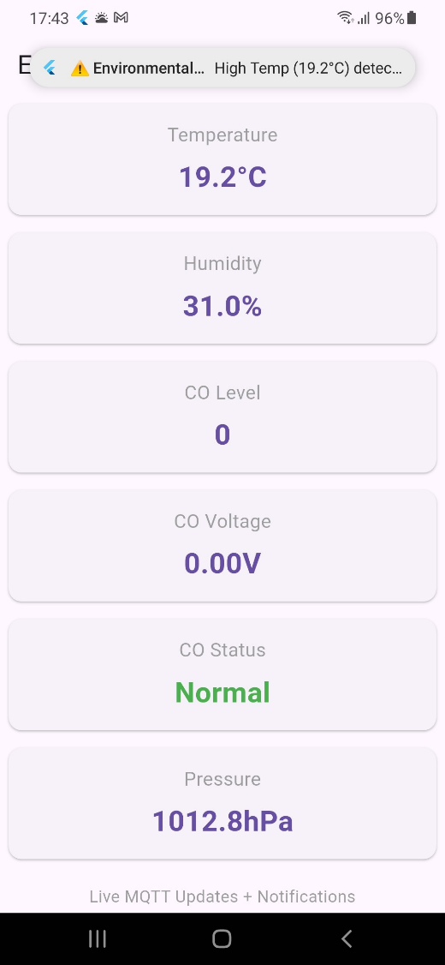

Here is a screenshot from the device to confirm that everything is working as expected.

# 5. Conclusions and Recommendations

## 5.1 Conclusion

This final year project presented significant challenges, primarily due to the complexities involved in programming and building the user interface. One of the most challenging aspects was developing a user-friendly application. As previously mentioned in this report, further research will be conducted after publication to ensure that all components are 100% compatible with one another.

It has been some time since I last used a CAD application to create a 3D model, so I sought guidance from Raj to reacquaint myself with its functions. Additionally, intermediate-level mathematics was necessary for calculating values related to the circuit, such as resistor values, as well as for designing the device's body.

The air monitor device is almost complete; by the time the demo occurs, the device will be fully crafted.

Overall, this project has taught me a great deal, including the importance of allocating more time to a project due to unforeseen factors that were previously unknown. For example, solar cells

## 5.2 Improvements

To have finished everything on time.

To use an independent backend server.

To develop an application in native Android Java/Kotlin (more freedom, yet more challenging).

To avoid damaging delicate components, such as infrared LEDs, again.

# 6. References

**[1]** R. Khandani, PIC Microcontrollers: An Introduction to Microelectronics, 3rd ed. New York: Cengage Learning, 2017.

**[2]** Arduino, “Arduino UNO Rev3,” RS Online, [Online]. Available: <https://uk.rs-online.com/web/p/arduino/6961667>

**[3]** K. T. Hanna and L. Rosencrance, “Google Firebase,” TechTarget, [Online]. Available: https://www.techtarget.com/searchmobilecomputing/definition/Firebase

**[4]** R. Brown, “How Do Pressure Sensors Work?,” Sciencing.com, [Online]. Available: <https://www.sciencing.com/thermistors-work-4709009/>

**[5]** National Fire Protection Association, “Ionization vs. Photoelectric Smoke Alarms,” NFPA.org, [Online]. Available: <https://www.nfpa.org/education-and-research/home-fire-safety/smoke-alarms/ionization-vs-photoelectric>

**[6]** Predictable Designs, “How to Pick the Right Voltage Regulators for Your Design,” Predictable Designs, [Online]. Available: <https://predictabledesigns.com/how-to-pick-the-right-voltage-regulators-for-your-design/>

**[7]** Digi-Key Electronics, “SICK Sensor Center,” Digi-Key, [Online]. Available: <https://www.digikey.co.uk/en/supplier-centers/sick>

**[8]** L. Da Xu, W. He, and S. Li, “Internet of Things in Industries: A Survey,” IEEE Transactions on Industrial Informatics, vol. 10, no. 4, pp. 2233–2243, Nov. 2014.

**[9]** R. H. Weber, “Internet of Things – New Security and Privacy Challenges,” Computer Law & Security Review, vol. 26, no. 1, pp. 23–30, Jan. 2010.

**[10]** M. Kumar, “Photoelectric Sensor Working Principle,” All About Circuits, [Online]. Available: https://www.allaboutcircuits.com/technical-articles/photoelectric-sensor-working-principle/

**[11]** Microchip Technology, “PIC Microcontrollers Overview,” Microchip.com, [Online]. Available: <https://www.microchip.com/design-centers/8-bit/pic-mcus>

**[12]** Google, “firebase_auth,” *pub.dev*, Accessed: Apr. 5, 2025. [Online]. Available: https://pub.dev/packages/firebase_auth

**[13]** Google, “firebase_core,” *pub.dev*, Accessed: Apr. 5, 2025. [Online]. Available: https://pub.dev/packages/firebase_core

**[14]** The Flutter Team, “flutter_mqtt_client,” *pub.dev*, Accessed: Apr. 5, 2025. [Online]. Available: https://pub.dev/packages/mqtt_client

**[15]** Google, “cloud_firestore,” *pub.dev*, Accessed: Apr. 5, 2025. [Online]. Available: <https://pub.dev/packages/cloud_firestore>

**[16]** SecureNest, “Guide to Starting Android App Development,” SecureNest.org, [Online]. Available: <https://securenest.org/guide-to-starting-android-app-development/>. Accessed: Apr. 7, 2025.

**[17]** A. Hameed, “Harnessing the Power of MQTT for the Future of IoT,” DZone, [Online]. Available: <https://dzone.com/articles/harnessing-the-power-of-mqtt-for-the-future-of-iot>. Accessed: Apr. 7, 2025.

**[18]** D. Thomas, “flutter_local_notifications,” pub.dev, [Online]. Available: https://pub.dev/packages/flutter_local_notifications. Accessed: Apr. 7, 2025.

**[19]** “ESP32 Board (WiFi + Bluetooth),” Amazon.co.uk, [Online]. Available: <https://www.amazon.co.uk/dp/B0D8T5P8JM>. Accessed: Apr. 7, 2025.